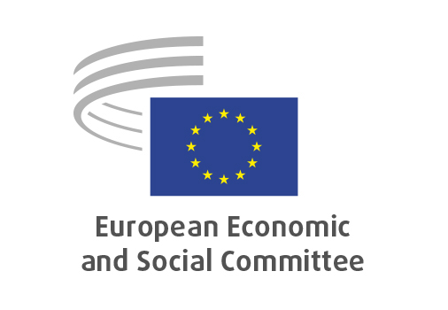
EN

SOC/855
EESC contribution to the EU's priorities at the UNCSW70

Brussels, 21 January 2026

RECORD OF THE PROCEEDINGS
European Economic and Social Committee
EESC Contribution to the EU's Priorities at the 70th session of the United Nations Commission on the Status of Women (UN CSW70)
Priority theme: Ensuring and strengthening access to justice for all women and girls
Review theme: Women’s participation in public life and ending violence against women
(Resolution)
_____________

602nd plenary session
Brussels
21-22 January 2026
_____________

Meeting of 21 January 2026
_____________

Agenda item 9
_____________

The president moved that the Committee turn to agenda item 9 - adoption of a resolution on the

EESC Contribution to the EU's Priorities at the 70th session of the United Nations Commission on the Status of Women (UN CSW70)
Resolution

The preliminary work had been carried out by the Section for Employment, Social Affairs and Citizenship (president: Cinzia DEL RIO). The rapporteurs were Giulia BARBUCCI, Juliane Marie NEIIENDAM and Christa SCHWENG.

The three rapporteurs presented the resolution that will serve as the EESC's contribution to the EU's priorities for the upcoming Seventieth session of the Commission on the Status of Women. Christa SCHWENG (GRI – AT) underscored that access to justice for all women and girls is essential for protecting human rights and strengthening democracy, that civil society plays an important role in addressing barriers to accessing justice, and that removing barriers means eliminating discriminatory laws, strengthening gender-responsive justice systems, accessible, affordable and quality legal aid. She concluded by stressing that when women and girls can claim their rights without barriers, societies become fairer and more democratic.

Juliane Marie NEIIENDAM (GRIII – DK) outlined the content and structure of the Resolution, starting with an assertion of the Committee's long-standing commitment to gender equality, women’s rights and the rule of law as core foundations of democracy, social justice and inclusive growth, the elimination of all forms of violence against women and girls, and the full and effective participation of women in economic, political and social life. According to the text, access to justice is both a fundamental human right in itself and a precondition for the implementation of other human rights such as gender equality. In terms of concrete actions proposed, she listed: (1) removing discriminatory laws, policies and practices; (2) strengthening gender-responsive justice systems; (3) improving access to affordable and quality legal aid and representation, (4) protecting survivors of violence; (5) improving digital access to legal information; and (6) removing socio-economic barriers. She finally called on member states to adopt and fund national action plans on access to justice.

Giulia BARBUCCI (GRII – IT) reminded that access to justice is enshrined in the Convention on the Elimination of All Forms of Discrimination against Women (CEDAW) and that it relates to Sustainable Development Goal number 16. She lamented that gender discrimination continues to create barriers for women's access to justice and stressed the importance of breaking down these structural barriers. Organised civil society, and EESC, should be able to help women access justice in situations of violence and exploitation.

EESC President Séamus BOLAND reviewed the contents of this contribution, also underlining that the Commission on the Status of Women reviews progress achieved in terms of past engagements as well. This year, it will assess women's participation in public life and eliminating violence, so he referred to the need to ensure: equal representation of women in political, economic and public decision-making; zero tolerance for gender-based violence; support and protection for women human-rights defenders and civil society organisations; safe, inclusive and democratic civic spaces; and support intersectional approaches, combat stereotypes and disinformation.
He concluded by saying that the EESC will continue promoting structured social and civil dialogue to support gender-responsive justice reforms, advocating gender mainstreaming and gender budgeting, and many more issues, while encouraging cooperation between EU institutions, Member States, social partners and civil society. By doing so we can achieve coordinated, whole-of-society approaches which deliver lasting results.

Some Members intervened in the exchange. Maria NIKOLOPOULOU (GRII – ES) congratulated colleagues for the well-structured and coherent document. This being the 3rd time the EESC will participate in UNCSW, this shows that the Committee is advancing internally; however, there is still a lot of work at a cultural level, as many stereotypes and forms of violence persist. Cinzia DEL RIO (GRII – IT) reminded that the EESC is also working on the Gender Equality Strategy [to be adopted by COM on March 4th]. The Committe has equally underlined that gender equality is important, namely combatting gender-based violence and increasing women's employment rates, especially in the care sector. Finally, she referred to some relevant work on female entrepreneurship.

The resolution was adopted by 189 votes to one, and three abstentions.

_____________

