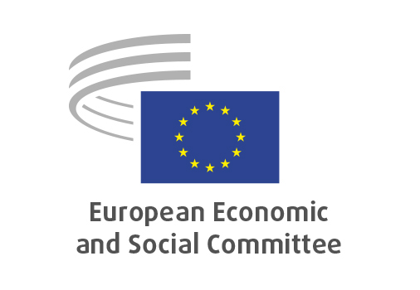
EN

ECO/684
Own resources – 2025 proposal

Brussels, 22 January 2026

RECORD OF THE PROCEEDINGS
European Economic and Social Committee
Proposal for a Council Decision on the system of own resources of the European Union and repealing Decision (EU, Euratom) 2020/2053
[COM(2025) 574 final - 2025/0574(CNS)]
_____________

602nd plenary session
Brussels
21-22 January 2026
_____________

Meeting of 22 January 2026
_____________

Agenda item 18
_____________

The vice-president, Ms Alena Mastantuono, moved that the Committee turn to agenda item 18 - adoption of an opinion on the

Proposal for a Council Decision on the system of own resources of the European Union and repealing Decision (EU, Euratom) 2020/2053
COM(2025) 574 final - 2025/0574(CNS).

The preliminary work had been carried out by the Section for Economic and Monetary Union and Economic and Social Cohesion (president: Ms Elena Calistru). The rapporteur was Ms Katrīna Zariņa and the co-rapporteur was Mr Petru Sorin Dandea.

The rapporteur and co-rapporteur presented the main political messages of the opinion, underlining that: it was a strategic choice of how the EU finances the political priorities of the Multiannual Financial Framework (MFF) in the coming years; repaying NextGenerationEU (NGEU) debt was about to start; the current system relied heavily on GNI based contributions by Member States and that a gradual shift away from those towards genuine own resources was necessary; as regards the CORE proposal the EESC had a cautious approach; the debate on own resources was not a new one and has been ongoing for years; a possible digital tax was very problematic at this stage as it could restart a trade conflict with the US.

In the ensuing general debate, Ms Elena Calistru and Mr Teppo Säkkinen took the floor mentioning that the EU needed enough resources for our spending priorities; that predictability of revenue was important, and that CBAM was in the first place not designed as a revenue instrument for the EU budget.

The rapporteurs replied that it was important to design how to apply in detail certain own resources, and that an agreement would be reached in the context of the overall MFF negotiations.

No amendments being tabled the opinion put straight to the vote and was adopted 208 votes to 3 with 4 abstentions.

_.____________

Gross National Income.
Corporate Resource for Europe.
Carbon Border Adjustment Mechanism.

