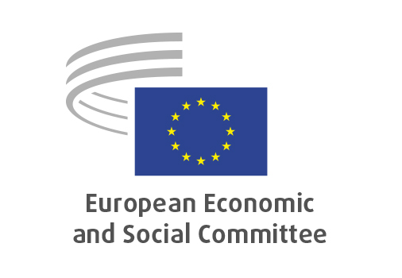
EN

NAT/966
Revision of the
Common Market Organisation (CMO) Regulation

Brussels, 21 January 2026

RECORD OF THE PROCEEDINGS
European Economic and Social Committee
Proposal for a Regulation of the European Parliament and of the Council amending Regulation (EU) No 1308/2013 as regards the school fruit, vegetables and milk scheme (‘EU school scheme’), sectoral interventions, the creation of a protein sector, requirements for hemp, the possibility for marketing standards for cheese, protein crops and meat, application of additional import duties, rules on the availability of supplies in time of emergencies and severe crisis and securities
[COM(2025) 553 final - 2025/0237(COD)]
_____________

602nd plenary session
held in Brussels
on 21 and 22 January 2026
_____________

Meeting of 21 January
_____________

Agenda item 6
_____________

The president moved that the Committee turn to agenda item 6 - adoption of an opinion on the

Proposal for a Regulation of the European Parliament and of the Council amending Regulation (EU) No 1308/2013 as regards the school fruit, vegetables and milk scheme (‘EU school scheme’), sectoral interventions, the creation of a protein sector, requirements for hemp, the possibility for marketing standards for cheese, protein crops and meat, application of additional import duties, rules on the availability of supplies in time of emergencies and severe crisis and securities
COM(2025) 553 final - 2025/0237(COD)

The preliminary work had been carried out by the Section for Agriculture, Rural Development and the Environment (president: Mr Stoyan TCHOUKANOV). The rapporteur was Mr Felipe MEDINA.

As the section had adopted its opinion with less than five votes against on 15 December 2025 and no amendments were tabled, the Committee decided unanimously not to hold a general discussion and to put the opinion straight to the vote (Rules 64(4) and 76(3)).

The opinion was adopted by the Assembly by 236 votes in favour, 1 vote against and 7 abstentions.

_____________

