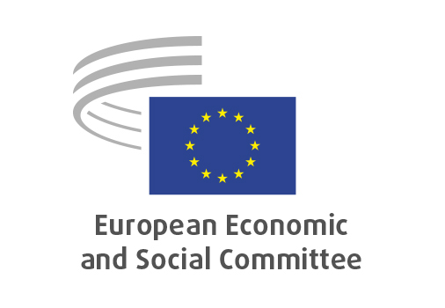
EN

INT/1104
Single Market and
Customs Programme 2028-2034

Brussels, 21 January 2026

RECORD OF THE PROCEEDINGS
European Economic and Social Committee
Proposal for a Regulation of the European Parliament and of the Council establishing the Single Market and Customs Programme for the period 2028-2034 and repealing Regulations (EU) 2021/444, (EU) 2021/690, (EU) 2021/785, (EU) 2021/847 and (EU) 2021/1077
[COM(2025) 590 final – 2025/0590 (COD)]
_____________

602nd plenary session
Brussels
21-22 January 2026
_____________

Meeting of 21 January 2026
_____________

Agenda item 6
_____________

The president moved that the Committee turn to agenda item 6 - adoption of an opinion on the

Proposal for a Regulation of the European Parliament and of the Council establishing the Single Market and Customs Programme for the period 2028-2034 and repealing Regulations (EU) 2021/444, (EU) 2021/690, (EU) 2021/785, (EU) 2021/847 and (EU) 2021/1077
COM(2025) 590 final – 2025/0590 (COD).

The preliminary work had been carried out by the Section for the Single Market, Production and Consumption (president: Ms Prouzet). The rapporteur was Mr de Mello.

As the section had adopted its opinion unanimously on 8 January 2026 and no amendments had been tabled, the Committee decided unanimously not to hold a general discussion and to put the opinion straight to the vote (Rules 64(4) and 76(3)).

The opinion was adopted by 239 votes, with six abstentions.

_____________

