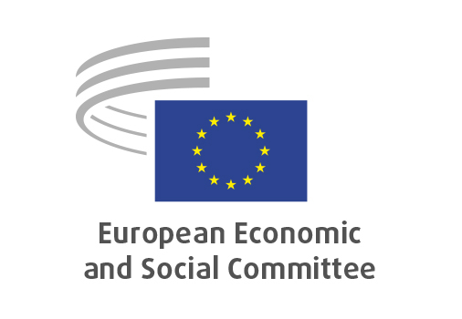
EN

REX/604
Boosting sustainable growth and quality jobs in Euromed

Brussels, 18 September 2025

RECORD OF THE PROCEEDINGS
European Economic and Social Committee
own-initiative opinion
_____________

599th plenary session
Brussels
17-18
_____________

Meeting of 18 September
_____________

Agenda item 33
_____________

The president moved that the Committee turn to agenda item 33 - adoption of an opinion on "Boosting sustainable growth and quality jobs in Euromed".

The preliminary work had been carried out by the Section for External Relations (president: Mr Dimitris Dimitriadis). The rapporteur was Ms Milena ANGELOVA (BG, I) and the corapporteur Mr Ioannis VARDAKASTANIS (EL, III).

As the section had adopted its opinion with less than five votes against on 9 July 2025 and no amendments had been tabled, the Committee decided unanimously not to hold a general discussion and to put the opinion straight to the vote (Rules 64(4) and 76(3)).

The opinion was adopted by 87 votes in favour and 5 abstentions.

_____________

