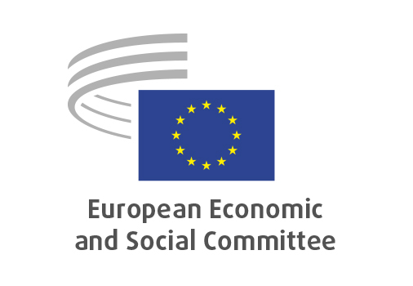
EN

ECO/687
Euro area economic policy 2026

Brussels, 21 January 2026

RECORD OF THE PROCEEDINGS
European Economic and Social Committee
Recommendation for a Council Recommendation on the economic policy of the euro area
[COM(2025) 957 final]
_____________

602nd plenary session
Brussels
21-22 January 2026
_____________

Meeting of 21 January
_____________

Agenda item 12
_____________

The president moved that the Committee turn to agenda item 12 - adoption of an opinion on the

Recommendation for a Council Recommendation on the economic policy of the euro area
COM(2025) 957 final.

The preliminary work had been carried out by the Section for Section for Economic and Monetary Union and Economic and Social Cohesion (president: Elena Calistru). The assembly ratified the appointment of Javier Doz Orrit as rapporteur-general, in accordance with Rule 79(2) of the Rules of Procedure.

In his introduction, Mr Doz Orrit highlighted the informal discussion held at the last ECO section meeting as integral for finding consensus and thus, avoiding Plenary amendments. He noted that the Commission's forecasts were rather positive, but there were huge geoeconomic and geopolitical risks and uncertainties. He underlined that the opinion largely agrees with the Commission's recommendations for the euro area, however, pointed out the lack of political unity, clarity and firmness. To illustrate, he mentioned the Banking and the Capital Markets Union as two major unfinished projects. He stressed the need for open capital markets, a stock of euro-denominated debt, the need to close the productivity and competitiveness gap, enhance Europe's strategic autonomy and strengthen its financial framework.

During the ensuing debate Mr Guerini and Mr Schwartz took the floor. They both congratulated the rapporteur. Mr Guerini stated that the opinion came at an important moment, especially as the European Parliament decided to refer the EU–Mercosur trade agreement to the Court of Justice. He regrated the lack of progress on completing the Banking Union and stressed the need for an autonomous and resilient EU economy. He noted that an autonomous financial system was crucial, mentioning the digital euro as a crucial step, but also calling for an EU-based payment solution. Mr Schwartz thanked the rapporteur for the emphasis on not allowing defence-related expenses direct attention away from other common challenges, like the environment or health. How the EU spent had to be carefully considered and the work on such common initiatives had to be continued.

In his reply, Mr Doz Orrit, thanked for the interventions and the support. He agreed that other type of expenses could not be sacrificed but noted the need for a common EU defence policy.

As no amendments has been tabled, the opinion had been put straight to the vote. It was adopted by 174 votes to 3 with 9 abstentions.

_____________

