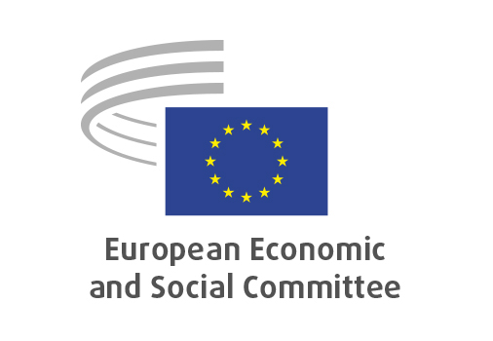
EN

INT/1117
Extension of Interim Rules / Online Child Sexual Abuse

Brussels, 21 January 2026

RECORD OF THE PROCEEDINGS
European Economic and Social Committee
Proposal for a Regulation of the European Parliament and of the Council amending Regulation (EU) 2021/1232 as regards the extension of its period of application
[COM(2025) 797 final – 2025/0429 (COD)]
_____________

602nd plenary session
Brussels
21 – 22 January 2026
_____________

Meeting of 21 January
_____________

Agenda item 5
_____________

The president moved that the Committee turn to agenda item 5 - adoption of an opinion on the

Proposal for a Regulation of the European Parliament and of the Council amending Regulation (EU) 2021/1232 as regards the extension of its period of application
COM(2025) 797 final – 2025/0429 (COD).

The preliminary work had been carried out by the Section for the Single Market, Production and Consumption, president Ms Émilie Prouzet.

Since the Committee endorses the content of the proposal and feels that it requires no comment on its part, it decided to issue an opinion endorsing the proposed text.

The opinion was adopted by 235 votes in favour, with three abstentions.

_____________

