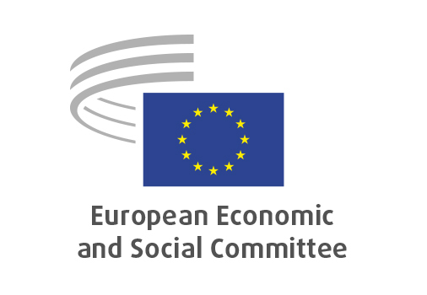
EN

NAT/975
Amendment to deforestation regulation (EU) 2023/1115

Brussels, 3 December 2025

RECORD OF THE PROCEEDINGS
European Economic and Social Committee
Proposal for a Regulation of the European Parliament and of the Council amending Regulation
(EU) 2023/1115 as regards certain obligations of operators and traders

(COM(2025) 652 final – 2025/0329(COD))
_____________

601st plenary session
Brussels
3-4 December 2025
_____________

Meeting of 3 December 2025
_____________

Agenda item 5
_____________

The president moved that the Committee turn to agenda item 5 - adoption of an opinion on the

Proposal for a Regulation of the European Parliament and of the Council amending Regulation
(EU) 2023/1115 as regards certain obligations of operators and traders
COM(2025) 652 final – 2025/0329(COD)

The preliminary work had been carried out by the Section for Agriculture, Rural Development and the Environment (president: Stoyan Tchoukanov).

Since the Committee has already set out its views on the content of the proposal in question in its opinions EESC-2024-01183-00-00-AC-TRA, adopted on 19/9/2024, and EESC-2021-05690-00-00-AC-TRA, adopted on 23/2/2022, it decided unanimously not to hold a general discussion and to put the opinion straight to the vote (Rules 64(4) and 76(3)).

The opinion was adopted by 207 votes in favour, 2 votes against and 8 abstentions.

_____________

EESC own-initiative opinion on Deforestation of the Amazon rainforest – impact on climate change and the global environment; consequences for companies, workers and population, OJ C/2024/6882, 28.11.2024
EESC opinion on Minimising the risk of deforestation and forest degradation associated with products placed on the EU market OJ C 275, 18.7.2022, p.88.

