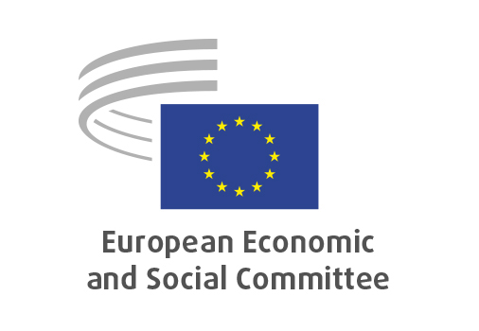
EN

INT/1094
Single Market Strategy

Brussels, 3 December 2025

RECORD OF THE PROCEEDINGS
European Economic and Social Committee
Communication from the European Commission to the European Parliament, The Council, the European Economic and Social Committee and the Committee of the Regions
The Single Market: our European home market in an uncertain world
A Strategy for making the Single Market simple, seamless and strong
[COM(2025) 500 final]
_____________

601st plenary session
Brussels
3-4 December 2025
_____________

Meeting of 3 December 2025
_____________

Agenda item 6
_____________

The president moved that the Committee turn to agenda item 6 - adoption of an opinion on the

Communication from the European Commission to the European Parliament, The Council, the European Economic and Social Committee and the Committee of the Regions – The Single Market: our European home market in an uncertain world
A Strategy for making the Single Market simple, seamless and strong
COM(2025) 500 final.

The preliminary work had been carried out by the Section for the Single Market, Production and Consumption (president: Emilie PROUZET). The rapporteurs were Emilie PROUZET, Angelo PAGLIARA and Giuseppe GUERINI.

As the section had adopted its opinion with less than five votes against on 14 November 2025 and no amendments had been tabled, the Committee decided unanimously not to hold a general discussion and to put the opinion straight to the vote (Rules 64(4) and 76(3)).

The opinion was adopted by 224 votes, with four abstentions.

_____________

