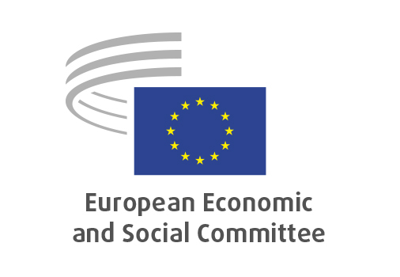
EN

SOC/846
Revision of the Carcinogens, Mutagens
and Reprotoxic substances Directive

Brussels, 23 October 2025

RECORD OF THE PROCEEDINGS
European Economic and Social Committee
Proposal for a Directive of the European Parliament and of the Council amending
Directive 2004/37/EC as regards the addition of substances and setting limit values in its Annexes I, III and IIIa
[COM(2025) 418 final - 2025/0232 (COD)]

_____________

600th plenary session
Brussels
22-23 October 2025
_____________

Meeting of 23 October 2025
_____________

Agenda item 27
_____________

The president moved that the Committee turn to agenda item 27 - adoption of an opinion on the

Proposal for a Directive of the European Parliament and of the Council amending Directive 2004/37/EC as regards the addition of substances and setting limit values in its Annexes I, III and IIIa
[COM(2025) 418 final - 2025/0232 (COD)]

The preliminary work had been carried out by the Section for the Employment, Social Affairs and Citizenship (president: Cinzia Del Rio).

Since the Committee endorses the content of the proposal and feels that it requires no comment on its part, it decided to issue an opinion endorsing the proposed text.

The opinion was adopted by 225 votes in favour, one against and six abstentions.

_____________

