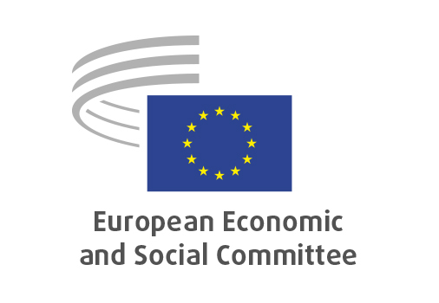
EN

NAT/964
Omnibus on chemicals

Brussels, 23 October 2025

RECORD OF THE PROCEEDINGS
European Economic and Social Committee
Proposal for a Regulation of the European Parliament and of the Council amending Regulation (EU) 2024/2865 as regards dates of application and transitional provisions
and
Proposal for a Regulation of the European Parliament and of the Council amending Regulations (EC) No 1272/2008, (EC) No 1223/2009 and (EU) 2019/1009 as regards simplification of certain requirements and procedures for chemical products
[COM(2025) 526 final – 2025/526(COD)
COM(2025) 531 final – 2025/531(COD)]
_____________

600 plenary session
Brussels
21-23
_____________

Meeting of 23rd of October
_____________

Agenda item 28
_____________

The president moved that the Committee turn to agenda item 28 - adoption of an opinion on the

Proposal for a Regulation of the European Parliament and of the Council amending Regulation (EU) 2024/2865 as regards dates of application and transitional provisions
and
Proposal for a Regulation of the European Parliament and of the Council amending Regulations (EC) No 1272/2008, (EC) No 1223/2009 and (EU) 2019/1009 as regards simplification of certain requirements and procedures for chemical products
COM(2025) 526 final – 2025/526(COD)
COM(2025) 531 final – 2025/531(COD)

The preliminary work had been carried out by the Section for Agriculture, Rural Development and the Environment (president: Mr Stoyan TCHOUKANOV). The rapporteur was Mr John COMER.

The rapporteur presented the opinion and highlighted that the European Economic and Social Committe welcomes the European Commission proposal and thanked everyone for the positive cooperation. In particular, he mentioned the following points:

- It is urgent to streamline and simplify this regulation in order to maintain balance and not hamper the industry and innovation.
- Human and environmental health should be prioritised and protected.
- Reducing complying cost and reduce administrative burdens for the chemical industry is the main priority.
- The simplification of the hazardous chemicals labelling rules should be given great importance as consumers must be informed and aware of what a product contains. Therefore, a consistent methodology should be undertaken, including easy readability and visibility of labels.
- Regarding CMR substances, it is important to make clear the conditions for derogation, in order to preserve human health and protect vulnerable groups.

In the ensuing debate, Mr TCHOUKANOV and Mr PUXEU ROCAMORA and Mr ALEMANY took the floor for their comments and expressed their support:

- It was underlined that looking for a consensus is the group’s added value and that human beings, particularly their health, should always be prioritized.
- It was mentioned the need for a transition period and the capacity to include amendments, and he asked to maintain this way of working in order to reach the broadest possible majority.
- It was stressed the importance of the REACH regulation, emphasizing the need to defend Europe’s strategic autonomy while simplifying the regulation.

Vote on the opinion as a whole
The opinion was adopted by the Assembly by 224 votes in favour, 1 vote against and 11 abstentions.

_____________

