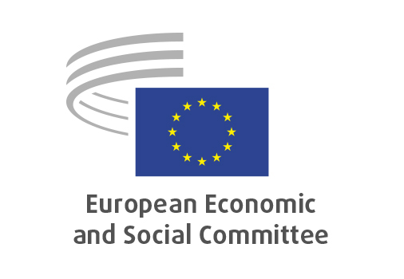
EN

INT/1091
State aid / Clean Industrial Deal

Brussels, 23 October 2025

RECORD OF THE PROCEEDINGS
European Economic and Social Committee
Framework for State Aid measures to support the Clean Industrial Deal
[COM(2025) 7600 final]
_____________

600th plenary session
Brussels
21-23 October 2025
_____________

Meeting of 23 October
_____________

Agenda item 29
_____________

The president moved that the Committee turn to agenda item 29 - adoption of an opinion on the

Framework for State Aid measures to support the Clean Industrial Deal
COM(2025) 7600 final.

The preliminary work had been carried out by the Section for the Single Market, Production and Consumption (president: Sandra Parthie). The rapporteur was Isabel Yglesias. During the plenary session, the rapporteur excused herself and was replaced by Teppo Seppänen.

The European Economic and Social Committee had decided, under Rule 79 of the Rules of Procedure, to appoint Mrs Yglesias as rapporteur-general.

Mr Seppänen presented the opinion. He explained that while State aid played a central role in enhancing EU industrial competitiveness, it must not undermine the integrity of the single market. There are disparities in aid-granting capacity across Member States, which should be mitigated through mechanisms that reward cross-border coordination and projects generating positive spill-over effects.

In the ensuing debate, Ms Murafa Benga, Ms Prouzet and Mr Wagener raised the following issues:
- the benefits of state aid for the internal market;
- the fact that these tools must be designed to reduce regional disparities;
- social clauses linked to the granting of state aid and the need to intensify social dialogue in order to speed up a just transition.

The opinion was adopted by 213 votes, with four abstentions.

_____________

