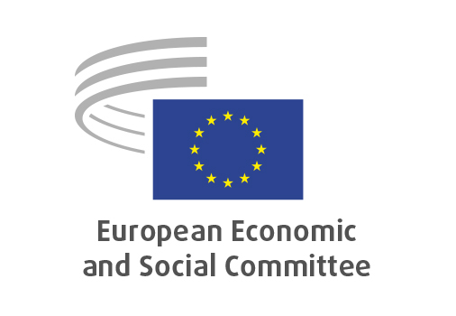
EN

REX/606
A New Pact for the Mediterranean

Brussels, 18 September 2025

RECORD OF THE PROCEEDINGS
European Economic and Social Committee
(Exploratory Opinion)
_____________

599th plenary session
Brussels
17-18 September 2025
_____________

Meeting of 18 September
_____________

Agenda item 9
_____________

The president moved that the Committee turn to agenda item 9 - adoption of an opinion on "A New Pact for the Mediterranean".

The preliminary work had been carried out by the Section for External Relations (president: Mr Dimitris Dimitriadis). The rapporteur was Mr Thomas WAGNSONNER (AT, II) and the corapporteur Ms Lidija Pavić-Rogošić (HR, III)

The rapporteur and the corapporteur presented the opinion.

In the ensuing discussion, MM de Mello, Wagnsonner, McLoughlin, de Felipe Lehtonen, Pagliara, Del Rio and Jahier took the floor and raised the following elements: the establishment of DG MENA as symbol for the strategic importance of the EU's Southern Neighbourhood, the possibility to set up a regional investment bank to finance the green transition, the new Pact for the Mediterranean's focus on youth, the role of public-private partnership to ensure the Pact's success, The Pact as a tool to counter Russian and Chinese influence in the Mediterranean region, the need to ground bilateral partnerships in the EU's founding values and the need to translate the Naples Process into concrete measures.

The opinion was adopted by 160 votes in favour, 1 vote against and 2 abstentions.

_____________

