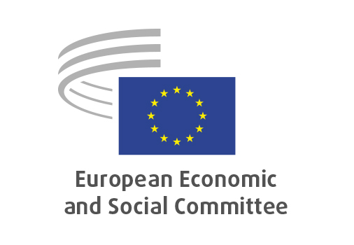
EN

NAT/949
Future of organic and quality food

Brussels, 18 September 2025

RECORD OF THE PROCEEDINGS
European Economic and Social Committee
Future of organic and quality food and how we can step up consumption
[own-initiative opinion]
_____________

599 plenary session
Brussels
17-18 September 2025
_____________

Meeting of 18th of September
_____________

Agenda item 13
_____________

The president moved that the Committee turn to agenda item 13 - adoption of an opinion on the

Future of organic and quality food and how we can step up consumption
(own-initiative opinion).

The preliminary work had been carried out by the Section for Agriculture, Rural Development and the Environment (president: Mr Peter SCHMIDT). The rapporteur was Mr Decebal-Ștefăniță PADURE and co-rapporteur was Ms Kerli ATS.

The rapporteur presented the opinion and highlighted that all food produced in the EU meets quality standards. However, the term ‘quality product’, as used in this opinion, refers exclusively to products certified under certification schemes, including organic products. Looking at the future of EU policy, means also looking at the environment. Quality strategies are needed, for rural development and for the climate. Certified organic food shall be available to consumers, at affordable prices and digital traceability shall be ensured. Small producers need support. In addition, there is also a need for better protection of the EU standards and quality marks on the global market. Local food is valued in this opinion and some instruments are suggested to step up consumption. We need to focus on how to increase production and use EU funds to engage consumers to choose quality products.

The co-rapporteur highlighted that there are many challenges in the organic and quality food sector, that need to be addressed. Organic farming is at a crossroads, consumer's choices are price-driven and demand is decreasing. There is a need to address the affordability issues related to the organic sector and therefore, we need to support the measures included in this opinion, to help boost the demand. With this opinion, we tried to look at different ways to boost the demand, so that consumers can choose local and quality food. The EU Organic Awards are very important, as they give visibility to the organic sector in the EU. Organic needs to reach Europeans, and this is what we addressed this with this opinion: how to ensure that European citizens are able to consume food that has been produced in Europe and that is quality food.

In the ensuing debate, the following members took the floor: Mr Peter SCHMIDT, Mr Marc DECOSTER, Ms Jarmila DUBRAVSKÁ, Mr Josep PUXEU ROCAMORA, Ms Isabel CAÑO AGUILAR. The members raised the following issues:

Mr Peter SCHMIDT:
- Important opinion for the EESC, also in link with the EU Organic Awards, that will take place next week. Important to raise awareness to the EU citizens about the importance of organic food.
- Farmers also should have better possibilities to get a decent price for their produce.
- Possible to unite organic and quality food.

Mr Marc DECOSTER:
- All EU products are quality products.
- The importance of choosing local food is stressed in the opinion.

Ms Jarmila DUBRAVSKÁ:
- Organic food is part of what we call quality food.
- Grateful to have farmers producing food, ensuring food security, and at the same time protecting the nature and the environment.
- Quality food from local producers increases food security.
- Need to ensure that farmers get better conditions for their produce.

Mr Josep PUXEU ROCAMORA:
- This opinion stresses the role of consumers and the way they perceive organic and quality food.
- There is a clear need for promotion and awareness raising, to ensure that there is a future for the producers and the sector.

Ms Isabel CAÑO AGUILAR:
- The opinion tackles various important issues, such as price, consumer's concerns and access to quality food.
- Need for a consistent food policy, that will promote local and quality food, and ensure that it is accessible to all.
- Quality food means also healthier European citizens.

Vote on the opinion as a whole
The opinion was put to vote and adopted by the Assembly by 149 votes in favour, no votes against and 2 abstentions.

_____________

