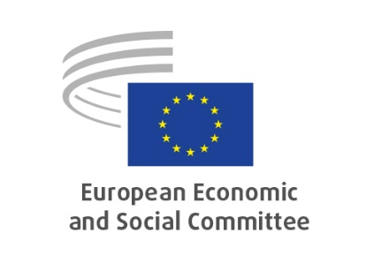

**EN**

1. ***Resolution* –** [***Defending the EU’s values and strengthening its future in the new geopolitical order***](https://www.eesc.europa.eu/en/documents/resolution/defending-eus-values-and-strengthening-its-future-new-geopolitical-order)

|  |  |
| --- | --- |
| **Rapporteurs** | Elena-Alexandra CALISTRU (Civil Society Organisations' Group - RO)  Antje GERSTEIN (Employers' Group - DE)  Luca JAHIER (Civil Society Organisations' Group - IT)  Winand QUAEDVLIEG (Employers' Group - NL)  Sophia REISECKER (Workers' Group - AT)  Peter SCHMIDT (Workers' Group - DE) |
| **References** | EESC-2025-02268-00-00-RES |

**Key points**

**The EESC:**

* highlights that Russia’s war in Ukraine and shifts in the U.S. administration mark a new geopolitical reality—driven by nationalism and authoritarianism—and signals that the era of global trade and open markets is fading;
* recommends that the EU must transform itself into a Security Union, achieve resilient strategic autonomy, and sharpen its global economic competitiveness. This shall be pursued while ensuring regulatory simplicity, reinforcing social cohesion, and fairly distributing wealth;
* calls for Member States to recommit to multilateralism. The increasing use of trade as a tool of coercion—especially since the U.S. introduced tariffs in April 2025—calls for EU resilience and renewed focus on bilateral partnerships;
* highlights that these challenges are not departures but rather urgent continuations of Europe’s founding mission. The EU, born as the greatest peace project after World War II, can serve as a global anchor of stability, democracy, and the rule of law. Responding with resolve and faith in European evolution is essential;
* affirms that the EU’s strength lies in its liberal democratic values—human rights, civil liberties, accountable governance, and vibrant civil society—and must remain central in Europe’s external posture;
* underlines that civil society plays a critical role. The EESC commits to serving as a watchdog and moderator, ensuring EU institutions remain grounded in democratic principles in navigating this new geopolitical order;
* affirms that democracy must rest upon fundamental principles:
  + All individuals and entities must enjoy equal access to justice and rights. Marginalised communities require special attention; independent, well-functioning courts are non-negotiable;
  + The Social Market Economy should balance competitive innovation with social protection, underpinned by social dialogue and equitable power-sharing;
  + Civic freedoms—including free expression and vibrant civil society—must be preserved. Yet the EESC also calls for decisive action against disinformation and hate speech in the digital realm;
  + Multilateralism, not nationalism, must guide EU cooperation. Addressing global challenges—such as war, climate change, food security—requires international collaboration;
  + Democratic processes must be inclusive and participatory. Decisions should emerge from dialogue and solutions, ensuring no stakeholder’s needs are overlooked or sacrificed;
* acknowledges the magnitude of current challenges yet remains optimistic. With political will and robust engagement from civil society, the EU can emerge more independent, economically robust, and socially peaceful. The EESC stands ready to bring civil society’s voice to the fore in shaping Europe’s future.

|  |  |
| --- | --- |
| ***Contact 1*** | *Pierluigi BROMBO* |
| *Tel.* | *+3225469718* |
| *Email* | *Pierluigi.Brombo@eesc.europa.eu* |
| ***Contact 2*** | *Lilla SZABÓ* |
| *Tel.* | *+3225468397* |
| *Email* | *Lilla.Szabo@eesc.europa.eu* |

_____________