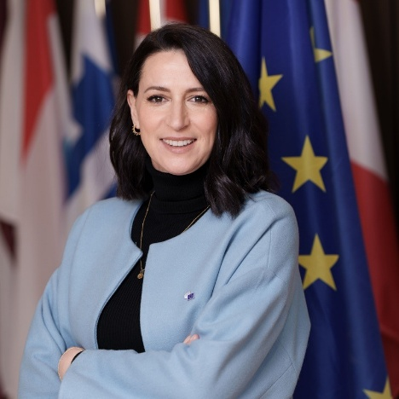 | Isabelle Le Galo Flores  Secretary-General as of 16 January 2024.  PROFESSIONAL CAREER:  2014 – 2023 – Deputy General Director of Daniel and Nina Carasso Foundation  2012 – 2014 – Director of Abracadabra Foundation  2009 – 2012 – Founder & CEO of Le Galo & Partners  2002 – 2009 – EMEA Web Communication Manager at Medtronic Europe and Communication and Director at Medtronic Spain
  LANGUAGE SKILLS:
  - Spanish
  - French
  - English

ACADEMIC CAREER:
2006 – Postgraduate Degree in Leadership Capability
Glasgow Caledonian University, United Kingdom

2000 – Master's degree in communication and media studies/international relations
Institut d'Etudes Politiques de Paris, France

1998 – Mathematical Engineering Degree
Polytech Clermont, France

FELLOWSHIPS AND AWARDS:
- Acumen Academy Fellowship since November 2023
- BMW Foundation Responsible Leaders Network since June 2023
- Aspen Institute Fellowship since January 2021
- Top 100 Women Leaders in Spain in December 2020

