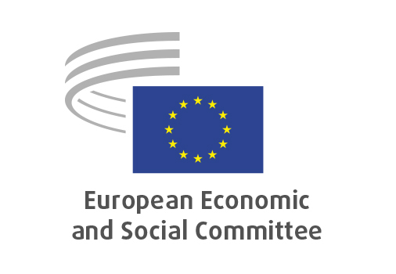
EN

ECO/668
A new impetus for the European sustainable finance framework

Brussels, 18 September 2025

RECORD OF THE PROCEEDINGS
European Economic and Social Committee

A new impetus for the European sustainable finance framework
(exploratory opinion requested by the Danish Presidency)

_____________

599th plenary session
Brussels
17-18 September 2025
_____________

Meeting of 18 September 2025
_____________

Agenda item 34
_____________

The vice-president moved that the Committee turn to agenda item 34 - adoption of an exploratory opinion on

A new impetus for the European sustainable finance framework.

The preliminary work had been carried out by the Section for Economic and Monetary Union and Economic and Social Cohesion (president: Mr Ioannis Vardakastanis). The rapporteur was Mr Javier Doz Orrit.

As the section had adopted its opinion with less than five votes against on 5 September 2025 and no amendments had been tabled, the Committee decided unanimously not to hold a general discussion and to put the opinion straight to the vote (Rules 64(4) and 76(3)).

The opinion was adopted by 94 votes in favour, with 3 abstentions.

_____________

