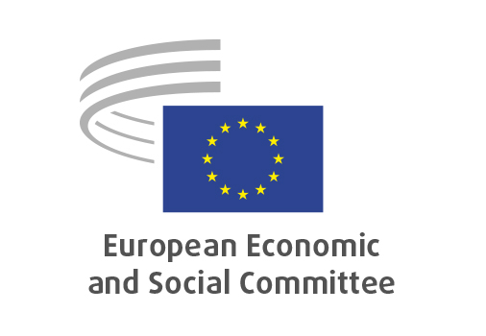
EN

CCMI/229
Low-carbon and renewable fuels

Brussels, 10 July 2024

RECORD OF THE PROCEEDINGS
European Economic and Social Committee
Low-carbon and renewable fuels: building the capacity of European industry to decarbonise the aviation and maritime sectors in a spirit of European autonomy
(own-initiative opinion)
_____________

589th plenary session
Brussels
10-11 July 2024
_____________

Meeting of 10 July 2024
_____________

Agenda item 6
_____________

The president moved that the Committee turn to agenda item 6 - adoption of an opinion on the

Low-carbon and renewable fuels: building the capacity of European industry to decarbonise the aviation and maritime sectors in a spirit of European autonomy
(own-initiative opinion).

The preliminary work had been carried out by the Consultative Commission on Industrial Change (President: Pietro Francesco De Lotto). The rapporteur was Anastasis YIAPANIS. The Co-rapporteur was Franck UHLIG.

As the section had adopted its opinion with no votes against on 6 June 2024 and no amendments had been tabled, the Committee decided unanimously not to hold a general discussion and to put the opinion straight to the vote (Rules 64(4) and 76(3)).

The opinion was adopted by 197 votes in favour, no against and 4 abstentions.

_____________

