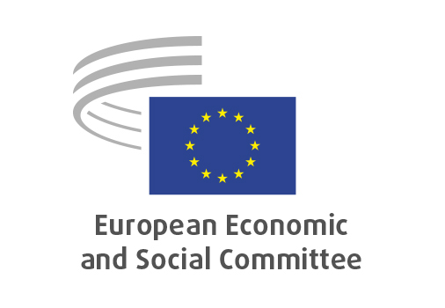
EN

SOC/820
Good practice for EU civil dialogue in the light of participatory processes

Brussels, 22 July 2025

RECORD OF THE PROCEEDINGS
European Economic and Social Committee
Good practice for EU civil dialogue in the light of participatory processes
[own-initiative opinion]
_____________

598th plenary session
Brussels
16-17 July 2025
_____________

Meeting of 16 July
_____________

Agenda item 5
_____________

The president moved that the Committee turn to agenda item 5 - adoption of an opinion on the

Good practice for EU civil dialogue in the light of participatory processes
Own-initiative opinion.

The preliminary work had been carried out by the Section for the Employment, Social Affairs and Citizenship (president: Cinzia Del Rio). The rapporteur was Arnaud Schwartz.

As the section had adopted its opinion with less than five votes against on 27 June and no amendments had been tabled, the Committee decided unanimously not to hold a general discussion and to put the opinion straight to the vote (Rules 64(4) and 76(3)).

The opinion was adopted by 183 votes to three and five abstentions.

_____________

