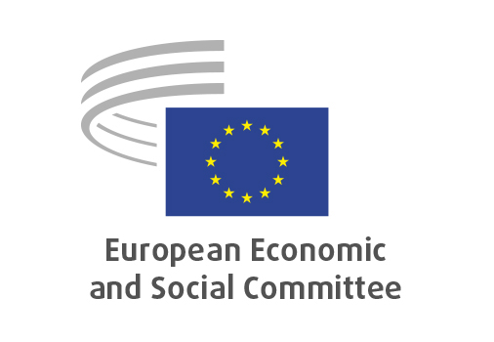
EN

NAT/959
Conservation and sustainable use of marine biological diversity of areas beyond national jurisdiction – ratification of BBNJ Agreement

Brussels, 16 July 2025

RECORD OF THE PROCEEDINGS
European Economic and Social Committee
Proposal for a Directive of the European Parliament and of the Council on the conservation and sustainable use of marine biological diversity of areas beyond national jurisdiction
[COM(2025) 173 final – 2025/90 COD]
_____________

598th plenary session
held in Brussels
on 16 -17 July 2025
_____________

Meeting of 16 July 2025
_____________

Agenda item 5
_____________

The president moved that the Committee turn to agenda item 5 - adoption of an opinion on the

Proposal for a Directive of the European Parliament and of the Council on the conservation and sustainable use of marine biological diversity of areas beyond national jurisdiction
[COM(2025) 173 final – 2025/90 COD]

The preliminary work had been carried out by the Section for or Agriculture, Rural Development and the Environment (president: Mr Peter SCHMIDT). The rapporteur was Mr Javier GARAT PÉREZ.

As the section had adopted its opinion with less than five votes against on 25 June 2025 and no amendments had been tabled, the Committee decided unanimously not to hold a general discussion and to put the opinion straight to the vote (Rules 64(4) and 76(3)).

The opinion was put to vote and adopted by the Assembly by 183 votes in favour, 1 votes against and 3 abstentions.

_____________

