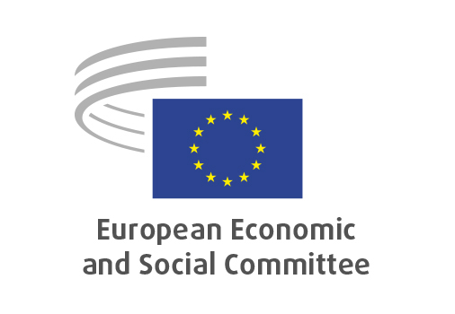
EN

INT/1082
The ERA Act: unlocking the fifth freedom

Brussels, 16 July 2025

RECORD OF THE PROCEEDINGS
European Economic and Social Committee
The ERA Act: unlocking the fifth freedom
[own-initiative opinion]
_____________

598th plenary session
Brussels
16-17 July 2025
_____________

Meeting of 16 July
_____________

Agenda item 5
_____________

The president moved that the Committee turn to agenda item 5 - adoption of an opinion on the

The ERA Act: unlocking the fifth freedom
Own-initiative opinion.

The preliminary work had been carried out by the Section for the Single Market, Production and Consumption (president: Sandra Parthie). The rapporteur was Paul Rübig and the co-rapporteur was Stefano Palmieri.

As the section had adopted its opinion with less than five votes against on 26 June and no amendments had been tabled, the Committee decided unanimously not to hold a general discussion and to put the opinion straight to the vote (Rules 64(4) and 76(3)).

The opinion was adopted by 186 votes to one and four abstentions.

_____________

