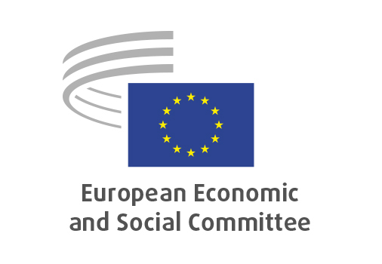
EN

ANNEX II
to the minutes of the
June plenary session

Brussels, 8 July 2025

ANNEX II
to the
MINUTES
of the 597th plenary session
of the
European Economic and Social Committee,
held in Brussels
on 18 and 19 June 2025
_____________
Meeting of 18 June 2025
_____________

Agenda item 10

Democratic Future of Belarus and signing of the Memorandum of Understanding between the EESC and the Belarusian democratic forces, with Sviatlana Tsikhanouskaya, leader of the Belarusian democratic forces

The EESC President, Oliver Röpke asked the Committee to turn to agenda item 10, a debate on the Democratic Future of Belarus and the signing of the Memorandum of Understanding between the EESC and the Belarusian democratic forces.
In his introductory remarks, the President highlighted the Committee’s ongoing support for Belarusian civil society, democracy and human rights. He noted that the signing of a Memorandum of Understanding (MoU) between the EESC and the Belarusian democratic forces would formalise cooperation and support joint initiatives for civil society, independent media and democratic advocacy.
Sviatlana Tsikhanouskaya, leader of the Belarusian democratic forces, thanked the EESC for its continuous support for Belarus and Ukraine and welcomed the signing of the MoU as a step towards a democratic future for Belarus and its people. She outlined five key areas of cooperation with the EESC, namely civil society, workers, businesses, independent media and awareness-raising activities. She noted that Belarusians living in the EU actively contributed to the European economy and to the communities in which they lived. She reiterated her plea for the unconditional release of all political prisoners in Belarus.
Maksim Pazniakou, acting chairman of the Belarusian Congress of Democratic Trade Unions (BCDTU), noted that 27 union leaders remain behind bars. He added that the BCDTU was the only internationally recognised trade union from Belarus and was a strong advocate of a peaceful dialogue between workers, employers and the state, and of respect for human rights and social justice.
Andrei Gnyot, Belarusian filmmaker and activist, shared his personal story – he was imprisoned in Serbia for more than seven years and released to the EU following international pressure, including from the EESC. He underlined the challenges faced by Belarusians in legalising their status in EU countries.
During the general debate, Jacek Krawczyk (PL-I), Lucie Studničná (CZ-II), Simo Tiainen (FI-III), Gintaras Morkis (LT-I), Tatjana Babrauskienė (LT-II), Michael McLoughlin (IE-III), Erika Koller (HU-II), Andris Gobiņš (LV-III) and Petru Sorin Dandea (RO-II) took the floor.

The following points were raised:
- Belarus has become a prolonged arm of the Kremlin’s regime
- Belarusian people deserve the EU’s attention
- Expression of full support for solidarity with Belarusian people
- Call for unconditional release of political prisoners
- Need for credible sanctions
- Accountability for those responsible for human rights violations
- Importance of involving of Belarusian experts in EESC work
- Spread of false info through AI algorithms
- Crucial role of people-to-people contacts
- The example of the MoU between the EESC and Belarusian democratic forces could be followed by other EU bodies
- Lack of objective information on Belarus

President Röpke and leader of the Belarusian democratic forces, Ms Tsikhanouskaya, then proceeded to sign the Memorandum of Understanding.

