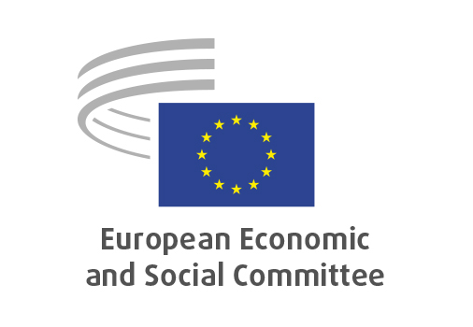

**EN**

**ECO/670**

**Communication on a Savings and Investments Union**

Brussels, 16 July 2025

**RECORD OF THE PROCEEDINGS**  
European Economic and Social Committee  
  
**Communication from the Commission to the European Parliament, the European Council, the Council, the European Central Bank, the European Economic and Social Committee and the Committee of the Regions on a Savings and Investments Union**

**A Strategy to Foster Citizens’ Wealth and Economic Competitiveness in the EU**

[COM(2025) 124 final]

_____________

598th plenary session  
  
Brussels  
16-17 July 2025

_____________

Meeting of 16 July 2025  
_____________

Agenda item 5

_____________

**The vice-president Plosceanu** moved to agenda item 5 - adoption of an opinion on the

*Communication from the Commission to the European Parliament, the European Council, the Council, the European Central Bank, the European Economic and Social Committee and the Committee of the Regions on a Savings and Investments Union - A Strategy to Foster Citizens’ Wealth and Economic Competitiveness in the EU*

COM(2025) 124 final

The preliminary work had been carried out by the Section for Economic and Monetary Union and Economic and Social Cohesion (president: **Ioannis Vardakastanis**). The rapporteur was **Petru Sorin** **Dandea**.

As the section had adopted its opinion with no votes against on 4 July 2025, and no amendments had been tabled, the Committee decided not to hold a general discussion and to put the opinion straight to the vote (Rules 64(4) and 76(3)).

The opinion was adopted by 184 votes to 2 with 5 abstentions.

_____________