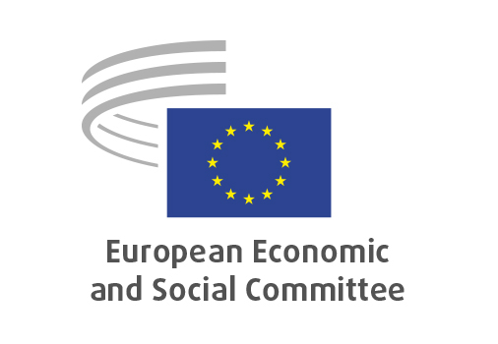
EN

CCMI/243
European defence industry programme

Brussels, 16 July 2025

RECORD OF THE PROCEEDINGS
European Economic and Social Committee
Proposal for a COUNCIL REGULATION establishing the Security Action for Europe (SAFE) through the reinforcement of a European defence industry instrument
COM(2025) 122 final
_____________

598th plenary session
Brussels
16-17 July 2025
_____________

Meeting of 16 July 2025
_____________

Agenda item 5
_____________

The president moved that the Committee turn to agenda item 5 - adoption of an opinion on the

Proposal for a COUNCIL REGULATION establishing the Security Action for Europe (SAFE) through the reinforcement of a European defence industry instrument
COM(2025) 122 final

The preliminary work had been carried out by the Consultative Commission on Industrial Change (president: Pietro Francesco DE LOTTO). The rapporteur was Maurizio MENSI. The co-rapporteur was Jan PIE.

As the section had adopted its opinion with less than five votes against on 10 July 2025 and no amendments had been tabled, the Committee decided unanimously not to hold a general discussion and to put the opinion straight to the vote (Rules 64(4) and 76(3)).

The opinion was adopted by 180 votes in favour, 5 vote against and 7 abstentions.

_____________

