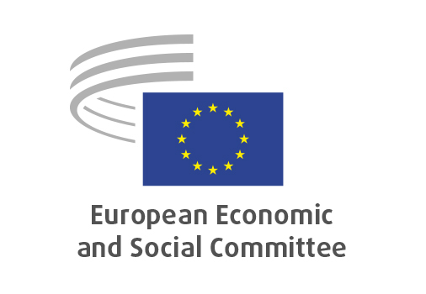

**EN**

**SOC/839**

**A roadmap for Women's Rights**

Brussels, 19 June 2025

**RECORD OF THE PROCEEDINGS**  
European Economic and Social Committee  
  
**Resolution on a Roadmap for Women's Rights -**

**Supporting the Declaration of Principles for a Gender-Equal Society**

_____________

597 plenary session  
  
Brussels  
18-19 June 2025

_____________

Meeting of 19 June 2025  
_____________

Agenda item 19

_____________

**The president** moved that the Committee turn to agenda item 19 - adoption of a resolution on

*A roadmap for Women's Rights -*

*Supporting the Declaration of Principles for a Gender-Equal Society*

The preliminary work had been carried out by the Section for Employment, Social Affairs and Citizenship (president: **Cinzia Del Rio**). The assembly ratified the appointment of **Sif Holst** as rapporteur-general, in accordance with Rule 79(2) of the Rules of Procedure.

The rapporteur-general presented the resolution as part of a debate, with interventions of **Hadja Lahbib**, European Commissioner for Equality, Preparedness and Crisis Management (video recorded message), **Irena Moozová**, Deputy Director-General of the European Commission Directorate-General for Justice and **Belén Sanz Luque**, Regional Director of UN Women Regional Office for Europe and Central Asia.

[c.f. CR on Agenda Item 18, EESC-2025-01645-04-00-PV].

The resolution was adopted by 177 to two votes, and ten abstentions.

_____________