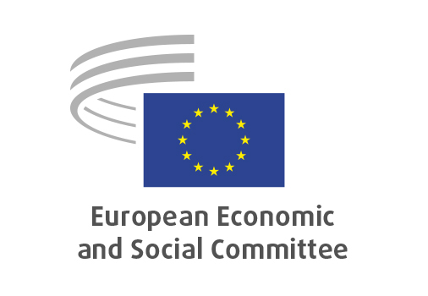

**EN**

**TEN/845**

The physical completion of EU’s internal market in the new geopolitical situation

Brussels, 26 February 2025

**RECORD OF THE PROCEEDINGS**  
European Economic and Social Committee  
  
**The physical completion of EU’s internal market in the new geopolitical situation**[own-initiative opinion]

_____________

594 plenary session  
  
Brussels  
26-27 February

_____________

Meeting of 26 February  
_____________

Agenda item 5

_____________

**The president** moved that the Committee turn to agenda item 5 - adoption of an opinion on the

*The physical completion of EU’s internal market in the new geopolitical situation*

(own-initiative opinion).

The preliminary work had been carried out by the Section for Transport, Energy, Infrastructure and the Information Society (president: **Baiba MILTOVIČA**). The rapporteur was **Päivi Elina WOOD**.

As the section had adopted its opinion without votes against on 5 February 2025 and no amendments had been tabled, the Committee decided unanimously not to hold a general discussion and to put the opinion straight to the vote (Rules 64(4) and 76(3)).

The opinion was adopted by 208 votes in favour and 2 abstentions.

_____________