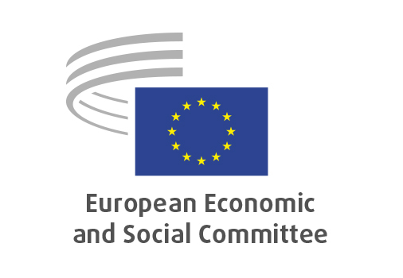

**EN**

**REX/587**

**Enhancing cooperation between CSOs**

**in the European Union and Kazakhstan**

Brussels, 26 March 2025

**RECORD OF THE PROCEEDINGS**  
European Economic and Social Committee  
  
**REX/587  
Action Plan for enhancing cooperation between civil society organisations in the European Union and Kazakhstan in the framework of the implementation of the New Strategy on Central Asia and of the Global Gateway**

**(own-initiative opinion)**

_____________

595th plenary session  
  
Brussels  
26-27 March 2025

_____________

Meeting of 26 March 2025  
_____________

Agenda item 12

_____________

**The president** moved that the Committee turn to agenda item 12 - adoption of an opinion on the

*REX/587*

*Action Plan for enhancing cooperation between civil society organisations in the European Union and Kazakhstan in the framework of the implementation of the New Strategy on Central Asia and of the Global Gateway*

The preliminary work had been carried out by the Section for **External Relations** (president: **Dimitris DIMITRIADIS**). The rapporteur was **Dumitru FORNEA (RO-II)**.

The rapporteur, Mr **Dumitru FORNEA**, presented the opinion, which was meant to diversify the EU international relations and to integrate previous EESC opinions which had been adopted before the launch of the EU Strategy for Central Asia. Meanwhile, the 5 Central Asian countries were getting increasing importance on the international scene and they tried to be cooperative and diversify their international relations, which had created a reciprocal interest in their relations to the European Union.

In 2023, the EESC had presented the opinion on the Global Gateway during the Central Asia Civil Society Forum in Tashkent. There would soon be the first Central Asia Summit in Samarkand, with the participation of the Presidents of the 5 countries, the European Commission and the EU Member States. Civil society should be present there as well.

Kazakhstan had been chosen for this own-initiative opinion since it was the most advanced country of the five, and the only one to have a functioning Enhanced Partnership and Cooperation Agreement (EPCA) with the EU. During the drawing-up of the opinion, a fact-finding mission in Kazakhstan had been organised, and we had an intense cooperation in this sense with the Kazakh Embassy in Brussels. The mission found out, as mirrored in the opinion, that Kazakhstan was the most EU-oriented Central Asian country and that, despite some persisting problems, it showed positive societal and political developments, as proved by a recent court decision.

In case the necessary budget was found, for example thanks to a support of the European Commission, the creation of Civil Society Platform with Central Asia should be explored, on the model of what the EESC was doing with other regions of the world.

Mr. **Kęstutis KUPŠYS** had been a member of the study group and recalled different stages of the work on the opinion. He supported the idea of continuing activities with Central Asian countries, but criticised the current setting in which the EESC had an internal body called "EU-Russia and Central Asia Follow-up Committee", since the former Soviet Republics should no longer be associated with Russia.

Mr. **FORNEA** replied that it was true that the Central Asian nations were fighting for their sovereignty and they should not be conceptually associated with any other countries.

Beyond raw materials, connectivity was another important topic connected to Central Asia: the EU was working on the Trans-Caspian International Transport Route as a railways and road corridor, which should be alternative to the Chinese Road and Belt Initiative but which would probably see some interconnection with it.

There had been 2 amendments tabled by Mr Stefano PALMIERI, which were accepted by the rapporteur.

|  |  |
| --- | --- |
| **AMENDMENT 1**  **REX/587**  **Action Plan for enhancing cooperation between civil society organisations in the European Union and Kazakhstan, in the framework of the implementation**  **Point 3.5.3**  **Insert new point**  **Position: After existing point - Same level** | **Tabled by:**  PALMIERI Stefano |

|  |  |
| --- | --- |
| ***Section opinion*** | ***Amendment*** |
|  | ***It should be noted that according the 2024 ITUC Global Rights Index, Kazakhstan has the rating 5: corresponding to no guarantee for workers’ rights, being one of the worst countries in the world to work in[1]. In this context of evident fragility for workers’ rights and for normal trade union activities, enhancing cooperation between civil society organisations in the European Union and Kazakhstan must necessarily pass through full respect for the rights of workers and independent trade unions.***  ***[1]*** [***https://www.ituc-csi.org/IMG/pdf/2024_ituc_global_rights_index_en.pdf***](https://www.ituc-csi.org/IMG/pdf/2024_ituc_global_rights_index_en.pdf) |

|  |  |
| --- | --- |
| **AMENDMENT 2**  **REX/587**  **Action Plan for enhancing cooperation between civil society organisations in the European Union and Kazakhstan, in the framework of the implementation**  **Point 1.5**  **Insert new point**  **Position: After existing point - Lower level** | **Tabled by:**  PALMIERI Stefano |

|  |  |
| --- | --- |
| ***Section opinion*** | ***Amendment*** |
|  | ***New first bullet point***   * ***Ensure constant independent monitoring, evaluation and implementation of: a) workers’ conditions, respect for workers’ rights and trade union activities; b) respect for human rights and non-discrimination; c) freedom of the press; d) certainty and respect of the rule of law.*** |

The opinion was adopted by 147 votes in favour, 0 votes against and 3 abstentions.

_____________