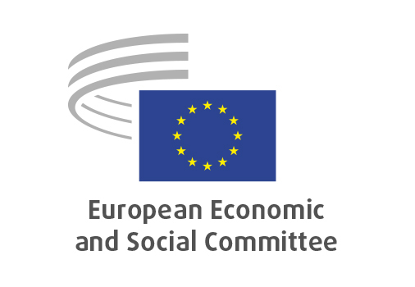

**EN**

**NAT/937**

**Amendment of the Common Markets Organisation (CMO) regulation**

Brussels, 27 March 2025

**RECORD OF THE PROCEEDINGS**  
European Economic and Social Committee  
  
**Proposal for a Regulation of the European Parliament and of the Council amending Regulations (EU) No 1308/2013, (EU) 2021/2115 and (EU) 2021/2116 as regards the strengthening of the position of farmers in the food supply chain**

[COM(2024) 577 final - 2024/0319 COD]

_____________

595th plenary session  
held in Brussels  
on 26 and 27 March 2025

_____________

Meeting of 27 March  
_____________

Agenda item 21

_____________

**The president** moved that the Committee turn to agenda item 21 - adoption of an opinion on the

*NAT/937 Proposal for a Regulation of the European Parliament and of the Council amending Regulations (EU) No 1308/2013, (EU) 2021/2115 and (EU) 2021/2116 as regards the strengthening of the position of farmers in the food supply chain*

COM(2024) 577 final - 2024/0319 COD

The preliminary work had been carried out by the Section for Agriculture, Rural Development and the Environment (president: **Mr Peter SCHMIDT**). The rapporteur was **Mr.** **Stoyan TCHOUKANOV.**

As the section had adopted its opinion with less than five votes against on 12 March 2025 and no amendments were tabled, the Committee decided unanimously not to hold a general discussion and to put the opinion straight to the vote (Rules 64(4) and 76(3)).

The opinion was adopted by the Assembly by 188 votes in favour, 3 votes against and 3 abstentions.

_____________