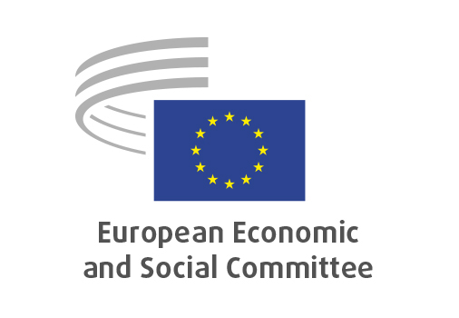
EN

ANNEX IV
to the minutes of the
February plenary session

Brussels, 27 February 2025

ANNEX IV
to the
MINUTES
of the 594th plenary session
of the
European Economic and Social Committee,
held in Brussels
on 26 and 27 February 2025
_____________
Meeting of 27 February 2025
_____________

Agenda item 15

Three years into Russia’s war on Ukraine: Defining the EU’s geopolitical future

EESC President Oliver Röpke asked the Committee to turn to agenda item 18 – the debate on Three years into Russia’s war on Ukraine: Defining the EU’s geopolitical future.
After introductory remarks, the President read the statement approved by the three EESC Groups on ‘Three years into Russia’s war on Ukraine: Defining the EU’s geopolitical future’. The full text of the statement can be found here.

Oksana Diakun, Deputy Head of Mission of Ukraine to the EU, emphasised that Ukraine had to prevail and that history had shown that appeasement of the aggressor could not work. She pointed out that Russia was no longer perceived as a hypothetical threat and was trying to break the international alliance in support of Ukraine. She added that the unity and determination of Europe was able to achieve the unthinkable, as shown in the first weeks of the invasion. As immediate measures to be taken, she mentioned:
- concrete decisions by the Special European Council on 6 March, dedicated to European defence and Ukraine,
- investment in the Ukrainian defence industry,
- continuation and strengthening of sanctions against Russia as loopholes still exist,
- use of immobilised Russian assets.
She concluded by saying that ‘peace through strength’ was the only viable solution for Ukraine, for Europe and for transatlantic unity.

José Ignacio Salafranca Sánchez-Neyra (ES-I), member of the Employers’ Group, called on the EU to take immediate and robust action in support of Ukraine. He noted that Europe needed to take measures to increase its competitiveness in order to be able to compete with economies such as China.

Veselin Mitov (BG-II), member of the Workers’ Group, noted the need to maintain solidarity with Ukraine.

Krzystof Stanisław Balon (PL-III), Member of the Civil Society Organisations’ Group, named actions to be taken by European civil society in support of Ukraine such as strengthening the EU’s preparedness and resilience, including measures against disinformation, and increasing awareness of the need for enhanced spending on defence.

During the general debate, Christian Moos (DE-III), Stefano Mallia (MT-I), Tatjana Babrauskienė (LT-II), Elena-Alexandra Calistru (RO-III), Peter Clever (DE-I), Javier Doz Orrit (ES-II), Michael McLoughlin (IE-III), Reet Teder (EE-I), Judith Vorbach (AT-II), Jan Torsten Andersson (SE-III), Simo Tiainen (FI-III) and Luca Jahier (IT-III), took the floor.

The following points were raised:
- Europe should not accept a peace that was imposed on Ukraine.
- The importance of defending the rules-based order in order to defend Europe.
- The Need to find alternatives to Russian oil and gas so that the EU is totally independent in that regard.
- The need to invest in education for Ukrainian children both in Ukraine and in exile.
- Next multiannual financial framework needs to be designed in support of democracy.
- The need to continue and step up the EU’s military aid for Ukraine.
- The importance of using frozen Russian assets in full to support Ukraine.
- The treats encountered by people on low and medium incomes in a war conflict.
______________

