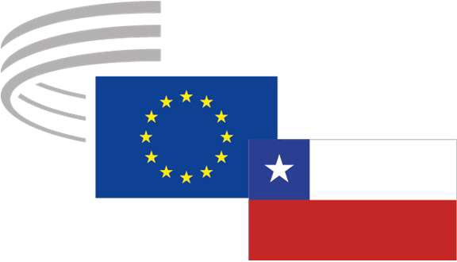

EN
Thirteenth meeting of the EU-Chile Joint Consultative Committee

Brussels, 31 January 2025

DECLARATION

Members of the EU-Chile Joint Consultative Committee (JCC) created in the framework of the 2002 EU-Chile Association Agreement (AA),

Reaffirming their commitment to the common values and principles shared by the EU and Chile, including the respect for democracy, human rights, rule of law, respect for human dignity and for multilateral rules-based order,

Considering the common challenges posed by the current evolving geopolitical circumstances, and concerned about challenges which exacerbate instability and hamper human development worldwide,

Considering the robust political, economic, cultural and cooperation ties between the EU and Chile, and acknowledging the meaningful relations between their organised civil societies represented in the JCC,

Acknowledge the results of the EU-Chile Association Agreement, which has provided a clear legal framework for a regular dialogue between the European and Chilean organised civil societies and created a platform serving not only to evaluate the implementation of the provisions of the agreement related to trade or sustainable development, but as a forum for exchanges on all issues of relevance for the partners.

Welcome the modernisation of the Agreement, which is essential to adapt relations between the EU and Chile to changing political, social and economic circumstances. They stress the importance of preserving and further strengthening the structured dialogue, developed within the JCC using the new instruments.

Welcome the swift ratification of the Interim Trade Agreement and its immediate entry into force. They urge the competent authorities to swiftly ratify and transparently implement the Advanced Framework Agreement and to avail themselves of the necessary impact assessments and monitoring tools to ensure the effective participation of organised civil society for the entire lifetime of the agreement.

Call on the authorities on both sides to highlight the positive lessons and best practices developed within the Joint Consultative Committee so that they can be used in the new mechanism provided for in the Agreement. They insist on ensuring appropriate financial support to strengthen the participation of the organised civil society represented, in line with the previously formulated requests.

Request that, in the context of possibly updating the agreement on trade and sustainable development, consideration be given to implementing mechanisms to maintain the levels of structured and permanent dialogue between European and Chilean civil society organisations.

The Chilean co-chair Pablo Bobic will report on the availability of the Ministry of Foreign Affairs to hold a meeting in Santiago in early April 2025, which will be examined in accordance with EESC rules.

