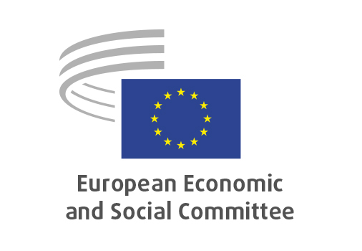

**EN**

**REX/592**

**Developing Europe’s strategy for the Arctic**

Brussels, 23 January 2025

**RECORD OF THE PROCEEDINGS**  
European Economic and Social Committee

**REX/592**

**Developing Europe’s strategy for the Arctic in dialogue with civil society**

(Own initiative opinion)

_____________

593rd plenary session  
  
Brussels  
22-23 January 2025

_____________

Meeting of 22 January 2025  
_____________

Agenda item 13

_____________

**The president** moved that the Committee turn to agenda item 13 - adoption of an opinion on the

*Developing Europe's strategy for the Arctic in dialogue with civil society*

*(Own-initiative opinion)*.

The preliminary work had been carried out by the Section for External Relations (president: **Dimitris DIMITRIADIS**). The rapporteur was **Anders LADEFOGED** and the co-rapporteur was **Christian MOOS**.

The **Rapporteur** and **Co-rapporteur** presented the opinion, which focuses on the Arctic region's fundamental and rapid transformation, bringing both opportunities and challenges. The Arctic has become a geopolitical hotspot, with all the world's superpowers vying for the upper hand. Critical raw materials in Greenland and the European Arctic could provide the EU with resilience, support its green transition ambitions, and contribute to enhancing competitiveness. For the EESC, it is clear that this can only be achieved if civil society is meaningfully involved and the rights of local and indigenous peoples are safeguarded

The following members took the floor during the debate:

**Teppo SÄKKINEN** supported the approach to engage with local communities of the Arctic. He also believed that the era of Arctic exceptionalism is no longer true given Russia's increased military build-up near the European Arctic, underscoring the need for NATO allies to be present.

**István KOMORÓCZKI** referred to President Trump's announcements about his interest to buy Greenland. He stated that the strategic importance of the Arctic has increased as both China and Russia pay more attention to the region.

**Krzysztof BALON** wondered what the Greenlandic civil society thinks about the possible options – status quo as an autonomous part of the Kingdom of Denmark, joining the United States or becoming independent.

**Ellen NYGREN** recalled that the EU's current Arctic strategy was adopted in 2021. As chair of the study group had participated in the interesting fact-finding mission in Nuuk in mid-October.

**Ágnes CSER** praised both the information report published in 2023 and the own-initiative opinion that was being discussed. She emphasised the need to consistently develop the social and health sector in the Arctic region.

**Simo TIAINEN** said that it is important for the EU to maintain a peaceful situation in the Arctic region. In connection with the pursuit of raw materials for the benefit of the EU's green transition, it was crucial that the needs of the local people were taken into account.

**Dumitru FORNEA** emphasised that it is important to ensure the EU's presence in the Arctic region and Greenland, while at the same time understanding the need for cooperation with the United States and Canada.

In their reply, **Mr LADEFOGED and Mr MOOS** stated that the speculation around Greenland was a recent development, so it was not discussed when the EESC delegation was in Nuuk. The EU could play a more important role as facilitator, and Denmark should seek backing from the EU instead of the Danish Prime Minister negotiating bilaterally with President Trump.

The opinion was adopted by 193 votes to 2 with 2 abstentions.

_____________