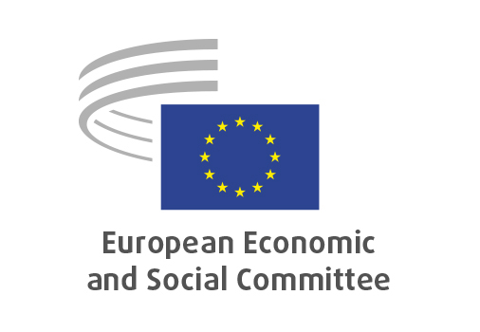
EN

NAT/928
Aligning the circular economy
and the bioeconomy at EU and national level

Brussels, 23 October 2024

RECORD OF THE PROCEEDINGS
European Economic and Social Committee
Aligning the circular economy and the bioeconomy at EU and national level
(own-initiative opinion)
_____________

591st plenary session
held in Brussels
on 23 and 24 October 2024
_____________

Meeting of 23 October
_____________

Agenda item 15
_____________
The president moved that the Committee turn to agenda item 15 and the vote on the opinion on

Aligning the circular economy and the bioeconomy at EU and national level
(own-initiative opinion).

The preliminary work had been carried out by the Section for Agriculture, Rural Development and the Environment (president: Mr Peter SCHMIDT). The rapporteur was Mr Cillian LOHAN.

The rapporteur highlighted that this own-initiative opinion is building on the innovative work on the circular economy and the fact that we have built a strong reputation. The opinion ensures that the bioeconomy strategy remains coherent with the work that has been done on circular economy as there is an overlap and the two topics need to be consistent with each other. Circular economy has been focusing more on the material flow and the research remained on the material side. Bioeconomy's focus is more on the biological part and the opinion stresses the opportunity for the EU to be a global leader in this space. The Bioeconomy strategy should be delivering on the SDGs and we need to ensure that practices are in line with circular economy.

In the ensuing debate, the following members took the floor: Mr Kükedi, Mr Hemmerling and Mr Schmidt. The members raised the following issues:
- bioeconomy and circular economy are going to help us achieve climate neutrality;
- it is important to ask the different involved DGs to work together on this topic;
- the opinion shows that it is not clear what bioeconomy is about as different concepts exist;
- bioeconomy will go into taxonomy in the future – we cannot ignore it now;
- the EESC calls for the establishment of a definition;
- the Committee is positioned as facilitator for discussion on bioeconomy.

Vote on the opinion as a whole

The opinion was put to vote and adopted by the Assembly by 191 votes in favour, 2 votes against and 3 abstentions.

_____________

