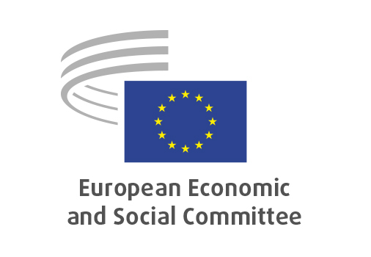
EN

INT/1066
Report on Competition Policy 2023

Brussels, 23 October 2024

RECORD OF THE PROCEEDINGS
European Economic and Social Committee
Report from the Commission - Report on Competition Policy 2023
[COM(2024) 115 final]
_____________

591st plenary session
Brussels
23-24 October 2024
_____________

Meeting of 23 October 2024
_____________

Agenda item 6
_____________

The president moved that the Committee turn to agenda item 6 - adoption of an opinion on the

Report from the Commission - Report on Competition Policy 2023
COM(2024) 115 final.

The preliminary work had been carried out by the Section for Single Market, Production and Consumption (president: Ms PARTHIE). The rapporteur was Mr GUERINI.

As the section had adopted its opinion at unanimity on 1st October 2024 and no amendments had been tabled, the Committee decided unanimously not to hold a general discussion and to put the opinion straight to the vote (Rules 64(4) and 76(3)).

The opinion was adopted by 246 votes with five abstentions.

_____________

