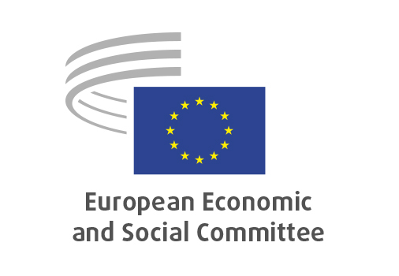

**EN**

**INT/1056**

**Public procurement/   
Social economy enterprises**

Brussels, 23 October 2024

**RECORD OF THE PROCEEDINGS**  
European Economic and Social Committee  
  
**Potential of public procurement for social economy enterprises**

(own-initiative opinion)

_____________

591st plenary session  
  
Brussels  
23-24 October 2024

_____________

Meeting of 23 October 2024  
_____________

Agenda item 6

_____________

**The president** moved that the Committee turn to agenda item 6 - adoption of an opinion on the

*Potential of public procurement for social economy enterprises*

(own-initiative opinion).

The preliminary work had been carried out by the Section for Single Market, Production and Consumption (president: **Ms** **PARTHIE**). The rapporteur was **Mr WYCKMANS** and the co-rapporteur was **Mr COHEUR**.

As the section had adopted its opinion unanimously on 1 October 2024 and no amendments had been tabled, the Committee decided unanimously not to hold a general discussion and to put the opinion straight to the vote (Rules 64(4) and 76(3)).

The opinion was adopted by 237 votes to one, with four abstentions.

_____________