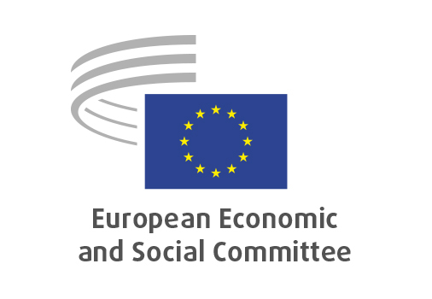
EN

REX/590
Screening of foreign investments in the Union

Brussels, 11 July 2024

RECORD OF THE PROCEEDINGS
European Economic and Social Committee
Screening of foreign investments in the Union
[COM(2024) 23 final]
_____________

589th plenary session
Brussels
10-11 July 2024
_____________

Meeting of 11 July
_____________

Agenda item 14
_____________

The president moved that the Committee turn to agenda item 14 - adoption of an opinion on:

Screening of foreign investments in the Union
[COM(2024) 23 final]

The preliminary work had been carried out by the Section for External Relations (president: Dimitris Dimitriadis). The rapporteur was Javier Doz Orrit.

The rapporteur started by thanking the Study Group and the Expert who worked on this Opinion, highlighting their availability, participation, and fundamental contribution.
The rapporteur then introduced the document by noting that the Commission’s proposal concerns a young regulation (2019), outgrown by the radically changed context over the past five years. In political terms, the EU introduced new policies like Open Strategic Autonomy and Economic Security, upon which mandate this proposal stands.
The rapporteur explained that there are serious gaps in the regulation as is, which the proposed review partially addresses.
The Groups agreed on the need of harmonisation, since it favours investment, as well as on the need for controls that are quick, effective and homogenous.
As to remaining areas of improvement, the rapporteur argued that in some exceptional circumstances, where the general interests of the Union and of most Member States (MS) are affected, the EU should introduce an overriding mechanism over single MS decisions.
In conclusion, the rapporteur also argued that the vigilance over tax havens-based companies should be in the hands of the Commission; it is a far-reaching threat that involves investments in real estate, crime, money laundering.

Three members took the floor.

Christian Moos (Germany, Group III) stressed that investments are important, and that EU needs open markets. However, he noted that China is no ordinary competitor; Chinese investors are no ordinary investors. The EU cannot afford to be naïve and should strive for reciprocity. The document captures that.
Christian Baumler (Germany, Group II) argued that we need to find balance between open markets and protection of interests. As stated in the opinion, the Commission proposes to fill gaps in the existing regulation, thus making it harder to exploit loopholes and weak links.
Andrés Barceló Delgado (Spain, Group I) praised the rapporteur for his excellent job and for the very balanced document. He concurred that harmonisation is much better than 27 different national regimes, but noted that overregulation is also bad, because it tends to generate corruption and loopholes.

In the concluding remarks, the rapporteur observed that reciprocity was discussed in the SG and it is an important precondition to any economic relationships going forward, as a key component of the Level Playing Field.

The opinion was adopted by 177 votes in favour and 2 abstentions.

_____________

