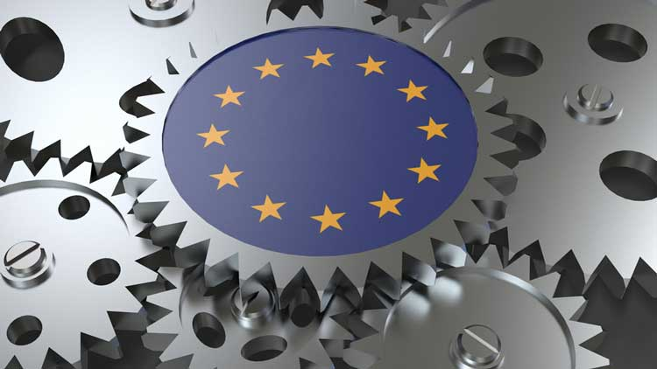

Competitiveness: EU’s Wake-Up Call
Statement by Sandra Parthie
President of the Section for the Single Market, Production and Consumption

If no decisive actions are being taken, the EU's share of the world economy will decrease significantly, threatening our welfare model and social systems. The EU must urgently improve the productivity and competitiveness of its economy. National governments increased tendency of putting alleged national interests first, renders the single market less efficient and leaves it fragmented. Start-ups and SMEs face challenges in expanding across borders, impacting economic potential and resilience. Businesses face growing regulatory costs and burdens from incoherent legislation while having only limited access to capital and investment.
To achieve its strategic goals and ensure that Europe can benefit from its still existing varied industrial base and its innovative companies and entrepreneurs, concerted action is necessary by prioritizing efficient access to financial resources and markets and by simplifying procedures as well as access to data.
Europe does have a competitive disadvantage with regard to resources like fossil fuels and raw materials vis à vis countries such as the U.S. and China. Industry and politics need to join forces in improving access to energy and raw materials under competitive conditions. While industry and companies can and must drive efforts to diversify energy sources and supply chains, politics must provide a supportive and adaptive regulatory framework, negotiate appropriate trade agreements, ensure the application of environmental and labour standards via public channels, and allow sufficient space for research and innovation, not least in the area of AI.
The EESC has produced a number of opinions and assessments on the EU’s state of competitiveness, providing insights and information from employers, employees and civil society actors. It now is going to hold decision-makers accountable for delivering on the priorities and goals, identified in e.g. the AI Act, the Critical Raw Materials Act, the Net-Zero Industry Act and the various elements of the Green Deal. The regulatory framework has been developed – now it needs to be made operational.

