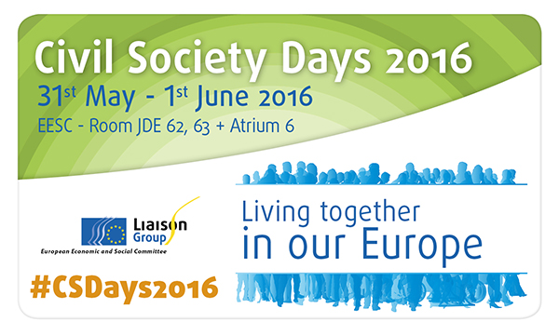

Workshop 3

Responses to the causes of migration

Wednesday, 31 May, 2.30 a.m. – 5.30 p.m.
Room JDE 63
Workshop 3: "Responses to the causes of migration" – organised by the EESC's REX section
Migration is currently a major topic of political and public attention in Europe. Migratory flows have never been bigger and they are forecast to double in the next 35 years. Its causes are multiple and it is impossible to present or discuss all necessary responses in one afternoon. But there are two facts that need to be underlined:
- The European Union need and will need migrants in its workforce and will likely be a top destination for migrants with or without a legal migrations system in place.
- There is a need to work with partner countries in addressing the socio-economic root causes of migration.
Therefore, to frame the issue, the REX workshop will focus first on medium term solutions such as promoting legal migration which can not only benefit the European labour market but also ensure a safer migration route for migrants.
The second panel will focus on the longer socio-economic development issues, with example of the work of civil society organizations in the countries sources of migration.
The workshop will be structured as follows:

14:30: Introduction
- Cristian Pîrvulescu, President of the Permanent Study Group on Immigration and Integration, EESC
14:40: 1st Panel: Promoting regular migration
- Sebastian Stetter, Policy Specialist, DG HOME, European Commission
- Geertrui Lanneau, Senior expert on labour migration and integration, IOM

* Discussion with participants

15:45 Coffee break

16:00: 2nd Panel: Brenda King, President of the Sustainable Development Observatory
From discussion to action, civil society initiatives to address causes of migration in an innovative manner, this panel will give the opportunity for civil organization from countries of origin to present their initiatives for inclusive economic development in different fields:
- Saadia Zrira, President and Founder, Association ASSID for Sustainable Development, Morocco
- Gbenga Sesan, Executive Director, Paradigm Initiative Nigeria (PIN), Nigeria
- Asma Mansour, Co- founder and president, Centre Tunisien pour l'Entreprenariat Social, Tunisia

* Discussion with participants

17:20: Conclusion and wrap up of the main message by the workshop rapporteur

17:30: End of workshop

