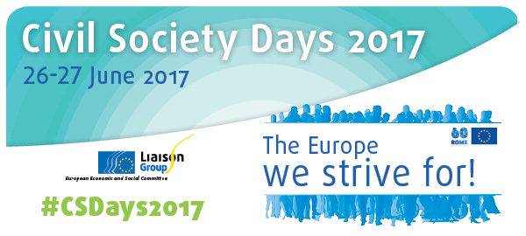

Workshop 3
Challenging right-wing populism:
The role of civic engagement, education and culture
Atrium 5
3 – 6 p.m.
Organised by Culture Action Europe (CAE), European Civic Forum (ECF), Volonteurope

Background
The European Union is facing an unprecedented crisis of legitimacy; support for its institutions and its strategic decisions is faltering. The erosion of trust in representative democracy and mainstream political parties, the economic crisis, and the ensuing dominance of austerity policies leading to animosity between Member States, combined with the EU’s current inability to come up with a positive approach to the flow of refugees, provide fertile ground for the resurgence of nationalism, authoritarianism and xenophobia. In many countries, from Hungary to Poland, the UK, the Netherlands, France, Germany, and Sweden, ultraconservative and extremist forces are gaining ground.
In the face of this continuous rise of extremist and authoritarian discourse in the public sphere, civil society plays a central role in taking up the challenge to ensure an inclusive Europe and oppose forces that are building walls, fragmenting our societies, rejecting the most vulnerable, and bringing back exclusion and nationalist sentiments.
The development of counter-narratives and the impact of civic engagement, education and culture on combatting right-wing populism and destructive anti-European positions clearly contribute to this goal.
Programme
1) IDEAS (1:00)
Intro and background: Alexandrina Najmowicz, European Civic Forum
Panel debate discussing the importance of community cohesion, civic education and culture in combatting right-wing populism, with:
- Juana Bengoa, Board Member of Volonteurope, Alianza por la Solidaridad, Spain
- Duje Prkut, researcher, advocacy officer, GONG, Croatia
- Yamam Al-Zubaidi, Riksteatern, Sweden
Moderation by Katherine Heid, Culture Action Europe
2) STORIES (1:30)
Three parallel breakout sessions (30 minutes each) to provide practical examples illustrating the role of civic engagement, community cohesion and volunteering, education and culture on combatting populism and its root causes. The speaker(s) will be supported by a facilitator from among the organisers. The Counterpoint facilitator will be present at all three sessions, so as to feed the thrust of the discussions into the capacity-building session the following day: "Countering anti-European populist rhetoric: the use of frames in our communication".

Initiatives to be showcased:
- Gemeinsam leben und lernen in Europe, Germany: Yannik Stefani, Luca Scholz and Amjad Abu Huwaij
- The Polish Women’s Strike (Black Monday protest against the abortion ban – Winner of European Citizenship Awards 2017 – Citizens’ initiative of the year): Marta Lempart
- ISIS Arts, UK: Clymene Christoforou
DEVELOPING SOLUTIONS (30’)
A series of policy recommendations will be collected during the sessions, presenting possible ways to encourage counter-narratives and steps forward. They will also serve as feedback on the sessions for all participants in the Civil Society Days as well as representatives of the institutions.

Short description of expected results
- deeper understanding of the impact of civic engagement, education and culture on combatting right-wing populism and its root causes
- sharing of good practices, at grassroots level, on how to combat right-wing populism
- reinforcing civil society’s capacity to channel civic discontent into positive action to combat the root causes of extremisms and build counter-narratives
- discovery of creative approaches to revive mobilisation, advocacy and citizen engagement
- development of input with regard to policy recommendations
- specific capacity-building tools

