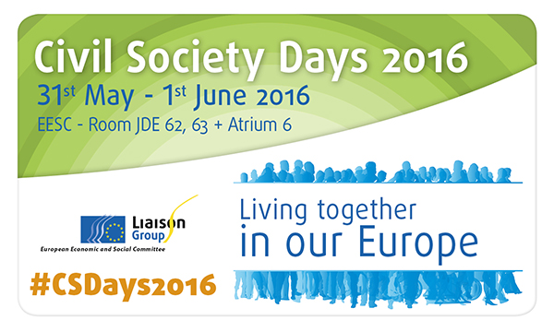

Workshop 2

Social Integration and CSOs

Wednesday, 31 May, 2.30 a.m. – 5.30 p.m.
Room JDE 62

Workshop 2: "Social Integration and CSOs" - Organised by CEV

This session will address the role of CSOs in helping citizens become socially integrated and will be approached in two parts. It will be opened by ‘scene setting’ inputs from the EESC's 'Social Affairs' section, CEV and Volonteurope.

This will be followed by the first panel discussion that will explore how CSOs contribute to ensuring that citizens have access to the services and protection measures needed in order to improve, or ensure a minimum, of economic and health security.

A second panel discussion after the coffee break will explore the role of CSOs in supporting social integration through developing cultural confidence and awareness in citizens and in facilitating their continued engagement with education (formal and non-formal), work and training.

The closing panel is entitled ‘Integration, CSOs and cross-sector partnerships’ and will include speakers from the business sector, and from London, the European Volunteering Capital 2016.

Opening Panel: ‘Value of CSOs for social integration’
- Lejla Šehić Relić, CEV, Volunteer Centre Osijek
- Laura de Bonfils, Volonteurope
- Pavel Trantina, European Economic and Social Committee

Panel 1: Explore how CSOs contribute to ensuring that citizens have access to the services and protection measures needed in order to improve, or ensure a minimum, of economic and health security.
- Denis Haveaux, Director, Red Cross EU Office
- Marida Bolognesi, President of SVS Pubblica Assistenza
- Luk Zelderloo, Director, EASPD
- Marie-Anne Paraskevas, Senior Policy Officer, Unit "ESF and FEAD: Policy & Legislation, DG EMPL, European Commission

Panel 2: Explore the role of CSOs in supporting social integration through developing cultural awareness & confidence in citizens and in facilitating their continued engagement with education (formal and non-formal), work and training.

- Jozo Radoš, Member of the European Parliament
- Mohammed Azahaf, Immigration and intercultural dialogue expert
- Katherine Heid, Culture Action Europe
- Antonio Silva Mendes, Director, Youth and Sport, DG EAC, European Commission
Closing panel: ‘Integration, CSOs and cross-sector partnerships’
- Natalie Cramp, European Volunteering Capital - London 2016
- David Frautschy, Telefonica S.A.
- Sara Queila Brito Lopes, CLW Woluwe

