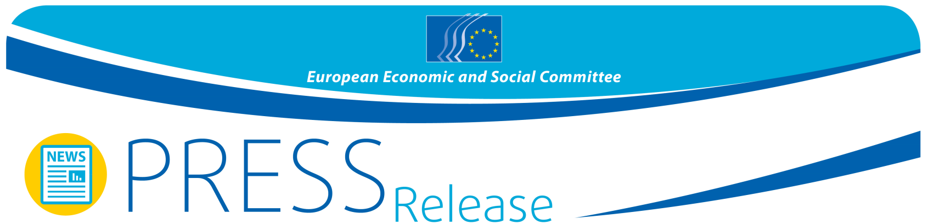

No 56/2015 | 18 September 2015

EESC calls for making better use of the Community Method for a Democratic and Social EMU:
A social union needs to be an integral part of the EMU, not an afterthought

"A genuine stabilisation of the economic and monetary union (EMU) needs a major correction in its construction and the appropriate accompanying reforms in order to finally complete it", says Gabriele Bischoff, rapporteur of the EESC opinion The community Method for a Democratic and Social EMU. The opinion takes stock of the strategic Five Presidents' Report on Completing Europe's EMU that was published in June, and makes several important proposals that the European social partners and civil society at large would like to see in the upcoming Commission initiatives in the field of EMU.

Without an effective investment plan to generate revenue through growth, social cohesion and solidarity, the current policy of primarily focusing on spending cuts is not merely ineffective, but has brought Europe to the brink of losing its economic integration, prosperity and social peace as a result of growing social inequalities.

We must leave this dangerous path now. While rectifying faults in the EMU's construction involves changing the treaties – a task which is not immediately feasible - the EESC calls for measures to enhance the democratic and social dimension of the EMU within the framework of the existing treaties:

- The EESC insists on closer involvement of the EP and national Parliaments in the design and monitoring of euro area economic policies and strongly recommends setting up a grand EP committee comprising all MEPs from the euro area and from the countries wishing to join it, combined with stronger coordination of members of national parliaments from the euro area on EMU issues under COSAC+.
- Economic policy goals must be brought in line with the EU's social policy objectives under Article 4(2) TFEU. To this end, all measures under the European Semester – in accordance with the horizontal social clause – must be subject to a social impact assessment.
- Divergences in the functioning of labour markets, wage-setting systems and welfare systems need to be removed.
- Last but not least, macroeconomic dialogue, an institutionalised form of discussion between the Council, the Commission, the European Central Bank and the European social partners, needs to be revived, with a particular focus on the euro area.

In its opinion, the European Economic and Social Committee (EESC) also criticises the political lethargy of the EU institutions, leaving the ECB to conduct European fiscal policy and other tasks which are outside its functional area. "We need to strengthen the social, political and economic cohesion in the EU and deepen economic and monetary integration as a basis for a properly functioning EMU. This requires the expertise and knowledge of all political stakeholders, including the social partners and the national parliaments", Ms Bischoff added. "Jean Claude Juncker's pledge in his first state of the union address to recreate a process of convergence, with productivity, job creation and social fairness at its core, is therefore one of the first silver lines on the horizon. Words now need to be translated into specific legislative initiatives by the Commission, and our opinion is intended to facilitate this process", concluded Bischoff.

More on the proposals for the democratic and social design of the EMU within the framework of the Community method can be found here.

For more information, please contact:
EESC Press Unit – Silvia Aumair
E-mail: press@eesc.europa.eu
Tel: + 32 2 546 8141 / +32 473 520 774
____________________________________________________________________________
The European Economic and Social Committee represents the various economic and social components of organised civil society. It is an institutional consultative body established by the 1957 Treaty of Rome. Its consultative role enables its members, and hence the organisations they represent, to participate in the EU decision-making process. The Committee has 353 members from across Europe, who are appointed by the Council of the European Union.
____________________________________________________________________________

