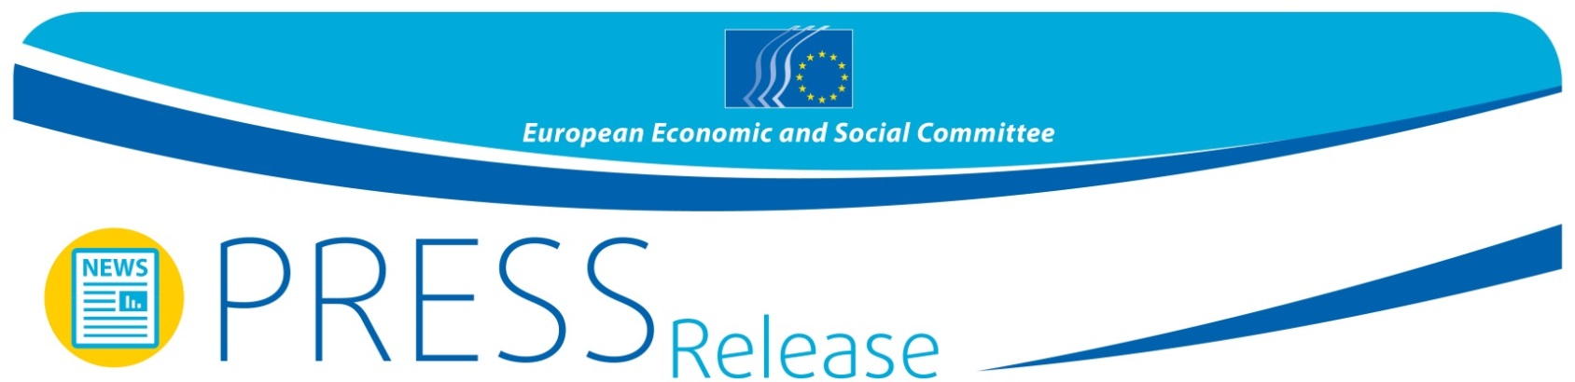
No 35/2015  EN | 4 June 2015
EN
Civil Society in the Balkans calls for more inclusion in the accession process

At the 5th Civil Society Western Balkans Forum on 2 and 3 June in Belgrade, participants acknowledged that despite some challenges, the perspective of EU accession will have significant impact on the Western Balkans. This was underlined during four thematic sessions of discussions with representatives of civil society organisations (CSOs) from Albania, Bosnia-Herzegovina, Kosovo, Montenegro, the Former Yugoslav Republic of Macedonia and Serbia.

Social partners and civil society organisations are essential partners in improving transparency and inclusiveness in the EU accession process. Participants therefore called on governments and EU institutions to strengthen the dialogue with CSOs and to improve access to information.

Corruption - biggest impediment to EU accession
The weaknesses of the rule of law, as well as corruption, have been identified as the biggest impediments to EU accession. Participants called on the countries in the region to implement the recommendations of the Groupe d'Etats contre la corruption (GRECO) as a first step to fight corruption. The implementation of accession benchmarks in terms of justice and the rule of law, as well as the protection of freedom of media are other necessary steps.

Increasing employment – a common challenge
The EU and the Balkans face high unemployment rates, with young people and women suffering in particular during the current crisis. Governments and EU institutions will need to prioritize the necessary means and conditions for increasing employment. Participants called for special support for young people and women.

Minority rights – strengthening the role of the Ombudsman
The respect of rights and freedoms related to ethnic, religious, linguistic, gender, and sexual orientation is still not effective in the Western Balkans. To improve the situation of minorities, participants proposed the reinforcement of the Ombudsman's role in the countries of the region, following the model of Albania, and to effectively implement legislation against discrimination.

The 5th Western Balkan Civil Society Forum ended with the adoption of a final declaration which will be forwarded to the national authorities in the region, the European Parliament, the European Council and other institutions.

For more information, please contact:
EESC Press Unit – Silvia Aumair
E-mail: press@eesc.europa.eu
Tel: + 32 2 546 8141 / +32 473 520 774
____________________________________________________________________________
The European Economic and Social Committee represents the various economic and social components of organised civil society. It is an institutional consultative body established by the 1957 Treaty of Rome. Its consultative role enables its members, and hence the organisations they represent, to participate in the EU decision-making process. The Committee has 353 members from across Europe, who are appointed by the Council of the European Union.
____________________________________________________________________________

