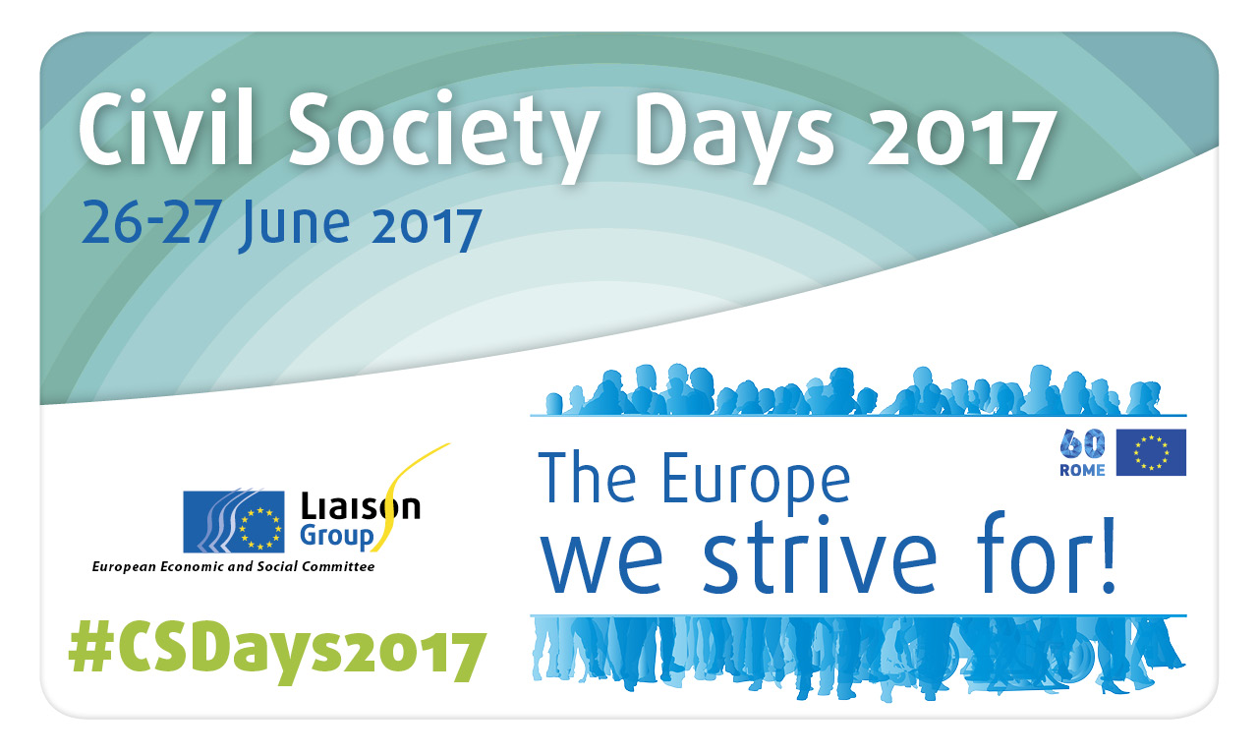

In the recent past the European Union has been facing disaffection from a significant proportion of its citizens. The financial crisis, wars around Europe, terrorist attacks and the large-scale arrival of refugees have led to resurgence in national egoism. The suspension of Schengen, Brexit and the rise of populism and authoritarian parties in many Member States threatens the very existence of the Union. What should have been a moment of celebration on 25 March 2017 actually revealed the shortcomings and limitations of the EU integration process.
Commission President Jean-Claude Juncker has put forward, in his 'White Paper on the future of Europe', five scenarios for an EU at 27, hoping to stir a debate leading to the European Council meeting of December 2017 and to relaunch the European project.
Civil society organisations are in a key position between citizens and European institutions, giving them the power to offer new perspectives for the Union and to propose concrete solutions for the future of Europe.
The Civil Society Days 2017 take up this challenge. As a framework, forming part of civil dialogue in line with Article 11 TEU, they are a unique chance for civil society organisations to contribute to this debate, thus bringing new impetus and show its continued support for to the European project.
It's time for civil society to raise its voice.
"The Europe we strive for!" will be organised civil society's call for a new political impulse to relaunch the EU on the basis of our values and roots and also give a clear commitment of civil society organisations to forge ahead.
It will focus on four themes:
- Populism, and how to develop a counter-narrative through education and culture;
- Technological revolution: transforming work, minds and society;
- Empowerment of civil society organisations, rights and the shrinking space for civil society;
- Urban and rural dimensions, moving towards more social and territorial cohesion.

Programme

26 June 2017

11 a.m.-1 p.m. Opening
Introduction by Gabriella Civico, European Volunteer Centre (CEV)
Welcome by Georges Dassis, EESC President
- Keynote speech: Global Europe and its role in peace and stability by
Federica Mogherini, High Representative of the European Union for Foreign Affairs and Security Policy, followed by a Q&A-session

- Discussion with representatives from the EU institutions and civil society, moderated by Conny Reuter (Solidar, Liaison Group co-chair):
  - Renate Weber, member of the European Parliament
  - Your Europe – your say 2017! Students Matěj Šulc (CZ), Markos Angelos Xeni (CY) and Bervin Demir (UK) presenting the recommendations on 'Europe@60 where to next?'
  - Adam Nyman (Friends of Europe): Debating Europe – presentation of an online debate on populism

Interpretation: EN/FR/DE/ES/IT into EN/FR/DE

1-2.30 p.m. Lunch reception

2.30-3 p.m.
Introduction by Brikena Xhomaqi, Director of the Lifelong Learning Platform (LLLP)
- Keynote speech on Technological revolution: transforming work, minds and society by Prof. Alberto Alemanno, Jean Monnet Professor of EU Law, HEC Paris and Founder of The Good Lobby

Interpretation: EN/FR/DE

3-6 p.m. First round of workshops
- New technologies and transition: Challenges and opportunities in the future of work organised by the European Youth Forum and the EESC SOC section – JDE 62
- Urban and rural dimensions: towards more social and territorial cohesion organised by Rurality-Environment-Development, European Countryside Movement and the EESC NAT section – JDE 63
- Challenging right-wing populism: The role of civic engagement, education and culture organised by Culture Action Europe (CAE), European Civic Forum (ECF) and Volonteurope – Atrium 5

6-8.00 p.m. Evening reception
Foyer 6th floor and Atrium 6
Introduction by Irini Pari, EESC member
- Exposition Animate Europe: Europe Fast Forward by the Friedrich Naumann Foundation for Freedom, introduction by Anna Reineke: The European and Transatlantic Dialogue Programme of the Friedrich Naumann Foundation for Freedom asked comic artists from all over the world what their understanding of Europe is and what they imagine Europe to look like in 50, 100 or even 200 years. The exhibition runs from 26 to 30 June 2017.
- Music by Refugees got talent

27 June 2017

9.30 a.m.-12.30 p.m. Second round of workshops
- New technologies and transition: What role for civil society in a future of e-democracy? organised by the European Citizen Action Service (ECAS) – JDE 62
- Countering anti-European populist rhetoric: The use of frames in our communication organised by Counterpoint – Atrium 5
- Empowering civil society to act and grow in Europe organised by the Social Platform – JDE 63

12.30-2.30 p.m. Lunch reception

2.30-4.30 p.m. Closing session

Introduction by Assya Kavrakova, Director of the European Citizen Action Service (ECAS)

- Keynote Speech on Populism by Gerald Hensel, founder of fearlessdemocracy.org / Digital transformation strategist
- Evelyne Gebhardt, Vice-President of the European Parliament
- Jean-Eric Paquet, Deputy Secretary General, European Commission
- Presentation of the results from the various workshops and debate
- Adoption of the 10 key demands and civil society commitments of the conference

Closing remarks by Conny Reuter, co-president of the Liaison Group and Secretary- General of Solidar

Interpretation: EN/FR/DE/ES/IT into EN/FR/DE

