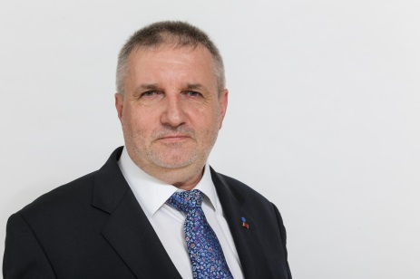
BALON Krzysztof (PL)

Representation: Poland

Languages: Polish, German, English, Russian

E-mail: K.Balon@depolsozial.de

My Organisation:

Wspólnota Robocza Zwiazków Organizacji Socjalnych (WRZOS)
ul. Nowy Świat 49/314
00-042 Warszawa
POLAND

+ 49-534-1-179.673
+ 49-534-1-841.113

Poland Working Community of Associations of Social Organisations (WRZOS) is a federation of 12 regional associations of non-governmental organisations and of some large social NGOs operating on the whole territory of Poland. In total there are over 550 NGOs in WRZOS organised with various types of activities, representing interests of and providing services for individuals and groups who are threatened or affected by social exclusion, such as disabled, elderly, homeless, and unemployed people.

What do I do?

I am the Secretary of the Programme Council of Working Community of Associations of Social Organisations (WRZOS). I am also the Managing Director of the Association for German-Polish Social Co-operation (Member of German Parity Social Association, DPWV) which is a platform for co-operation between social NGOs from Germany, Poland and also from other countries in Middle and Eastern Europe for the common work for the improvement in the structural conditions of the development of social NGOs and for development of international pilot projects with regard to social, family, youth, disabled and senior citizen politics.

My professional background is the social management (MSc. at the Donau-University Krems, Austria).

URL: http://www.wrzos.org.pl

