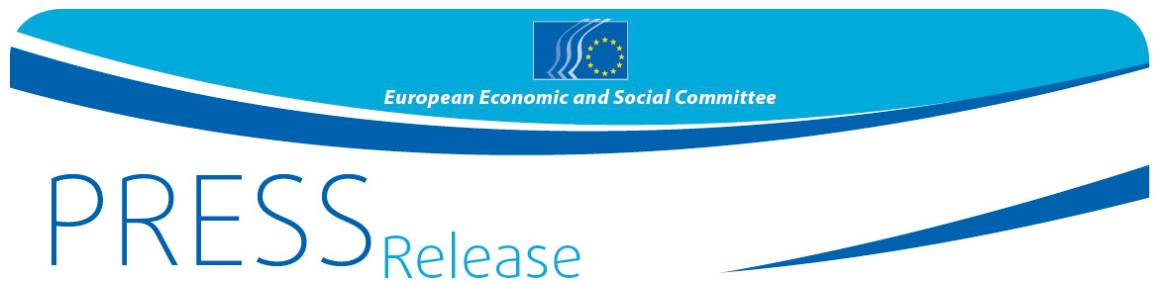
No 50 /2017 | 5 October 2017

Civil society strengthens dialogue between the European Union, Latin America and the Caribbean despite the postponement of the EU-CELAC Summit

More than 120 participants took part in the 9th Meeting of European Union, Latin American and Caribbean organised civil society, which took place on 3rd and 4th October in Panama City. Representatives of civil society organisations from the EU, Latin America and the Caribbean, of regional and national advisory bodies, employers' organisations, trade unions, and other economic and social organisations expressed their regret about the postponement and possible cancellation of the EU-CELAC Summit 2017, which was planned to take place at the end of October 2017 in El Salvador.

"We decided to move forward with this meeting to promote and strengthen the dialogue between the two regions," said Dilyana Slavova, the President of the Section for External Relations of the European Economic and Social Committee. "We cannot forget that the EU is the main investor in and donor to Latin America and that the countries of Latin America and the Caribbean are the EU's second largest trading partner."

The participants in the meeting emphasised that the participation of organised civil society was vital for successful negotiations between the EU and CELAC. In the agreements between the two regions, civil society participation should take place via institutionalised and adequately funded joint follow-up committees.

Civil society from both regions urged political leaders to propose multilateral solutions for achieving the UN Sustainable Development Goals, in a global context of ongoing conflicts where comprehensive action is needed, with achievable and binding negotiated commitments.

Particular attention was paid to the mobility of knowledge between the two regions and the positive impact it has on innovation and boosting the economy. Migratory flows and exchanges of knowledge were pointed out as key contributors towards better integration of the two regions.

For more information, please contact:

EESC Press Unit – Siana Glouharova
+ 32 (0)2 546 92 76 – Mobile: + 32 (0) 473 53 40 02
siana.glouharova@eesc.europa.eu
@EESC_PRESS
VIDEO: How has the EESC made a difference?

The European Economic and Social Committee is an institutional consultative body established by the 1957 Treaty of Rome. The Committee has 350 members from across Europe, who are appointed by the Council of the European Union. It represents the various economic and social components of organised civil society. Its consultative role enables its members, and hence the organisations they represent, to participate in the EU decision-making process.

If you no longer wish to receive these messages, please send an e-mail to: press@eesc.europa.eu

